Association of Writers & Writing Programs
Contact: Juanita R. Lester, Director of Communications
awpPR@awpwriter.org

FOR IMMEDIATE RELEASE

AWP Hosts Hybrid 2022 Conference & Bookfair in Philadelphia, Pennsylvania (March 23–26)

USA, Jan 21, 2022 — The Association of Writers & Writing Programs (AWP) returns to an in-person conference March 23–26, 2022, in Philadelphia, Pennsylvania. Following a successful virtual conference in 2021 with over 6,000 attendees, the Association of Writers & Writing Programs will also host online prerecorded events for attendees who would like to participate from home.

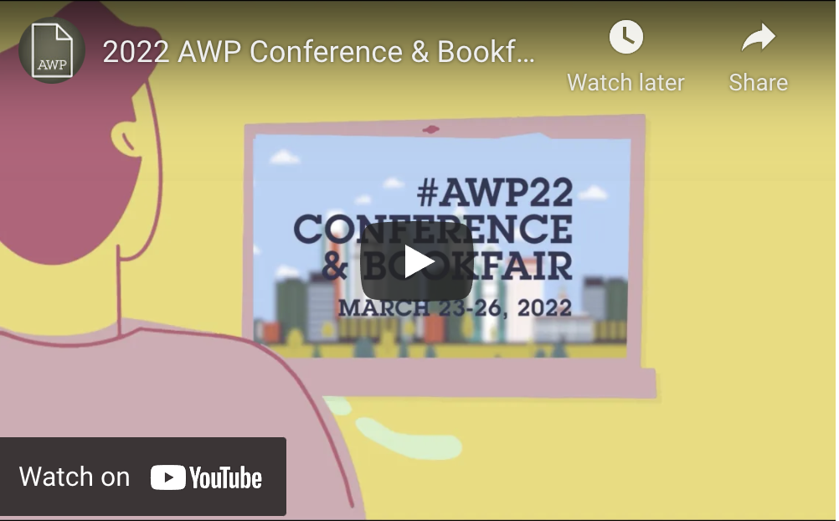

Celebrated poet Toi Derricotte will give the 2022 AWP Conference & Bookfair keynote address on Thursday, March 24, 2022, at 8:30 p.m. ET. Attendees onsite in Philadelphia will have access to over 200 events, reduced from the usual 500-plus to accommodate COVID-19 health and safety policies as mandated locally and nationally. One hundred virtual events, along with select onsite events, can be streamed online for a month post-conference so that both in-person and online attendees can watch the events they missed—and re-watch their favorites!

Attendees can look forward to popular returning events such as Writer to Agent and Ask an Agent Anything. The bookfair, which will only be available onsite, will provide an opportunity for attendees to connect with editors, small presses, publishers, and literary magazines. Both online and onsite attendees can take advantage of the virtual conference platform to connect with writers near and far.

A statement about the upcoming 2022 AWP Conference & Bookfair
“After successfully reimagining the conference as a virtual-only space for 2021, returning to an in-person gathering this year brings a new sense of excitement and anticipation. The AWP staff has worked hard to achieve a safe in-person conference while still providing that wonderful, interactive virtual offering for those who join us online.” –Cynthia Sherman, AWP Executive Director
Visit the AWP website for information on registration, scheduled events, and featured events.

For additional information, contact the conference department at conference@awpwriter.org.
For images and social media content, contact the communications department at awpPR@awpwriter.org.

For more information or to speak with someone about the 2022 AWP Conference, please contact Juanita Lester at awpPR@awpwriter.org.

