AWP’s Twenty-third Tweet Chat: #TellAWP17
February 23, 2017 from 3:00-4:30 p.m. ET

AWP‏@awpwriter
In just one hour, we'll be chatting with you about the #AWP17 Conference & Bookfair. Please share your experiences using #TellAWP17.
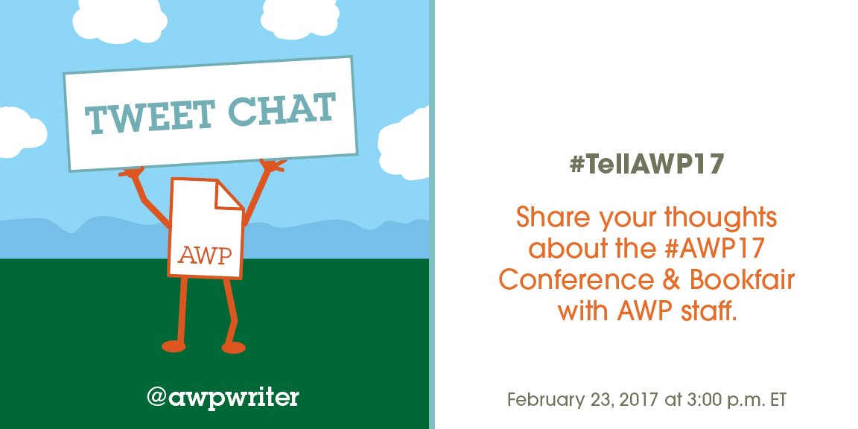

AWP‏@awpwriter
Welcome to the #TellAWP17 tweet chat discussing your feedback and experiences at the 2017 Conference & Bookfair in Washington, DC.
AWP‏@awpwriter
The conference staff is live for the next hour to respond to your #TellAWP17 feedback.
AWP‏@awpwriter
With us are AWP's Director of Conferences @ChristianTeresi and Director of Exhibits @cshermanva. #TellAWP17
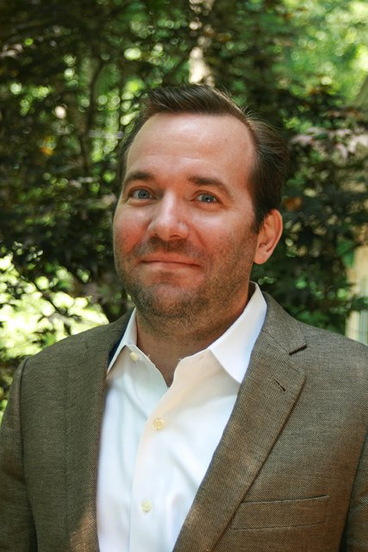 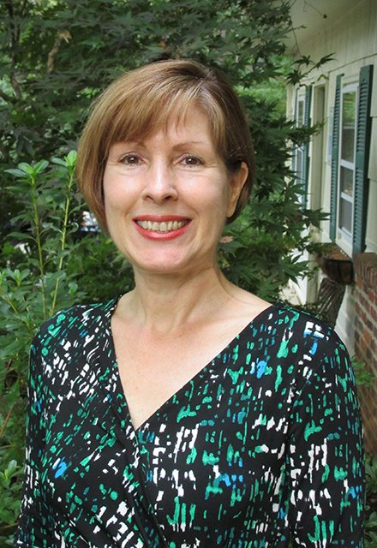
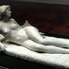George's Dryad‏@GeorgesDryad
@awpwriter @ChristianTeresi @cshermanva Good to meet you. Plz #TellAWP17 that we need doors that work #CripLit

AWP‏@awpwriter
Also here are Registration Coordinator @AWPsTiffany and Events Coordinator Colleen Cable @colleen_cable. #TellAWP17
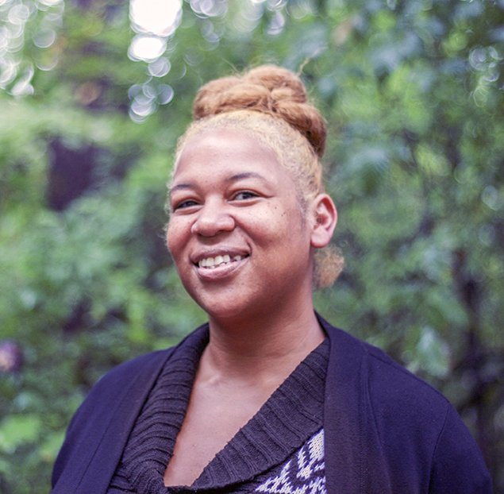 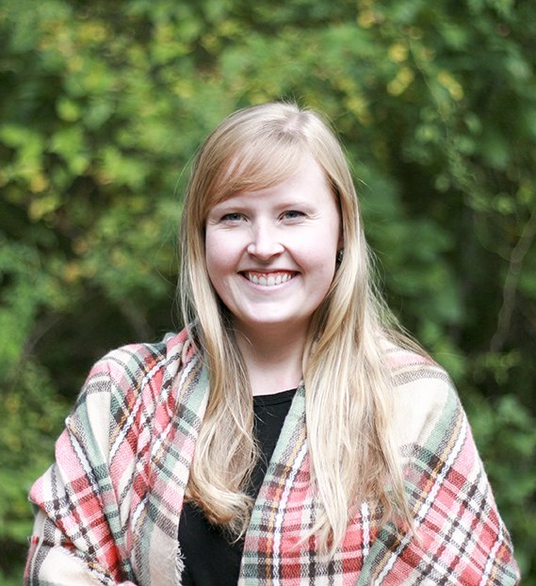
George's Dryad‏@GeorgesDryad
@awpwriter @AWPsTiffany @colleen_cable Good to meet you! Plz #TellAWP17 that we need ramps to get on stages

Christian Teresi‏@ChristianTeresi
Did you attend #AWP17 in DC? Please complete this #TellAWP17 survey & help us create a better conference: https://www.awpwriter.org/awp_conference/survey …
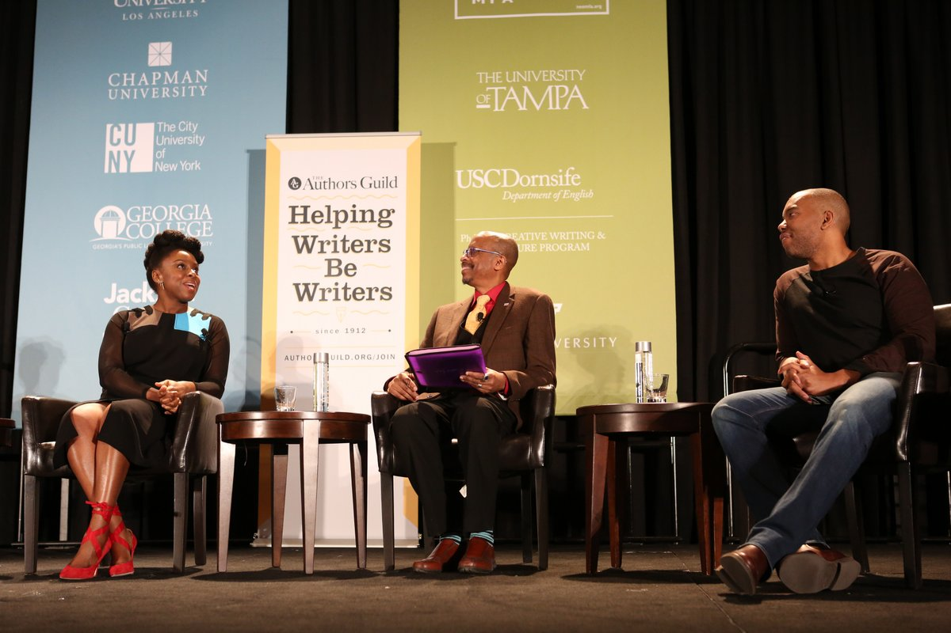

Tiffany‏@AWPsTiffany
Thank you to all that attended #AWP17 it was a pleasure meeting you in the registration area! #TellAWP17
AWP‏@awpwriter
Feel free to leave your #AWP17 Conference & Bookfair feedback any time during the #TellAWP17 chat.
Tiffany‏@AWPsTiffany
Over 250 students & adjunct professors volunteered for #AWP17. Thank you for your service you were a HUGE help! #TellAWP17
Christian Teresi‏@ChristianTeresi
The #AWP17 conference staff is live until 4 PM EST to respond to your #TellAWP17 feedback and questions. Let us know what you think.
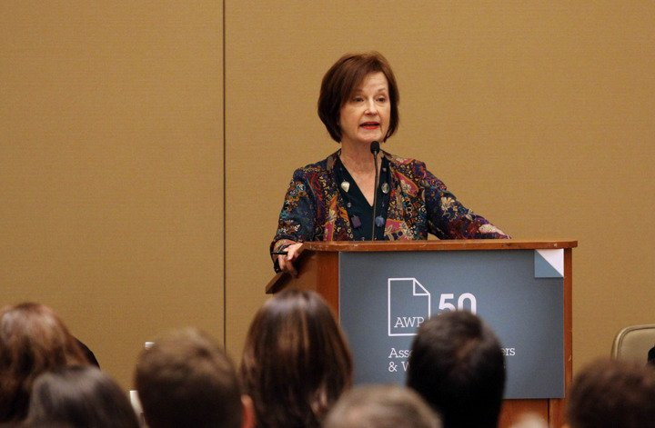
Jenee Darden‏@CocoaFly
@ChristianTeresi I would like to see more publishers of color. This was my 1st time & I enjoyed it. #TellAWP17
Christian Teresi‏ @ChristianTeresi
@CocoaFly We welcome any publisher or press that wants to come to the bookfair. We send out extensive solicitations. We would love that too.

Mrs. Judd‏@mrs_mjudd
Had a great time presenting at AWP!#TellAWP17
Mrs. Judd Retweeted Mrs. Judd
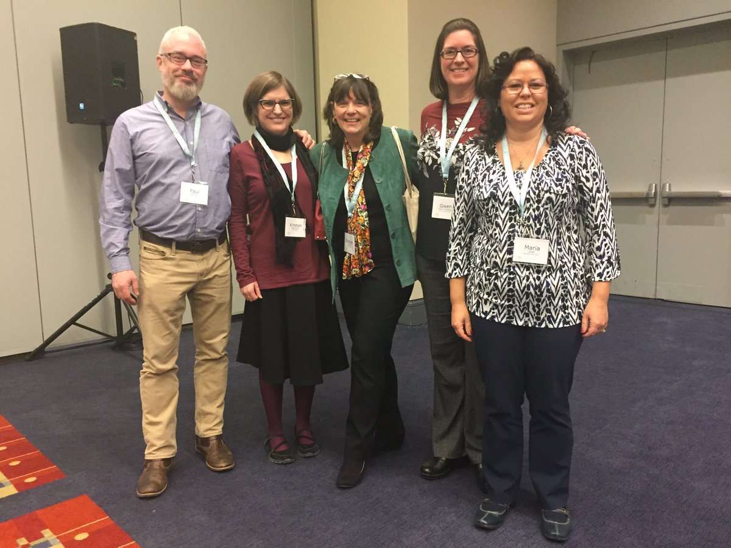
Mrs. Judd@mrs_mjudd
Presenting with professors at the AWP conference!@StreetsboroHS

Cynthia Sherman‏@cshermanva
#TellAWP17 Thank you bookfair exhibitors and attendees for such a great bookfair!
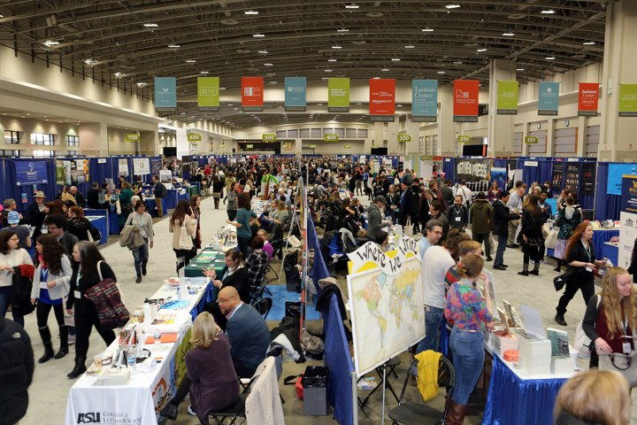
Lisa Romeo‏@LisaRomeo
@ChristianTeresi If you don't mind a suggestion, I think it might work better for the tweet feedback if you asked questions. #TellAWP17
Christian Teresi‏ @ChristianTeresi
Thanks @LisaRomeo. Have you filled out the survey? https://www.awpwriter.org/awp_conference/survey …
Lisa Romeo‏ @LisaRomeo
@ChristianTeresi I did yes - that was a great follow-up to get so soon, while fresh in mind. #TellAWP17

Cynthia Sherman‏@cshermanva
#tellawp17 Bookfair fun! Thank you, Poetry Fox, love my poem
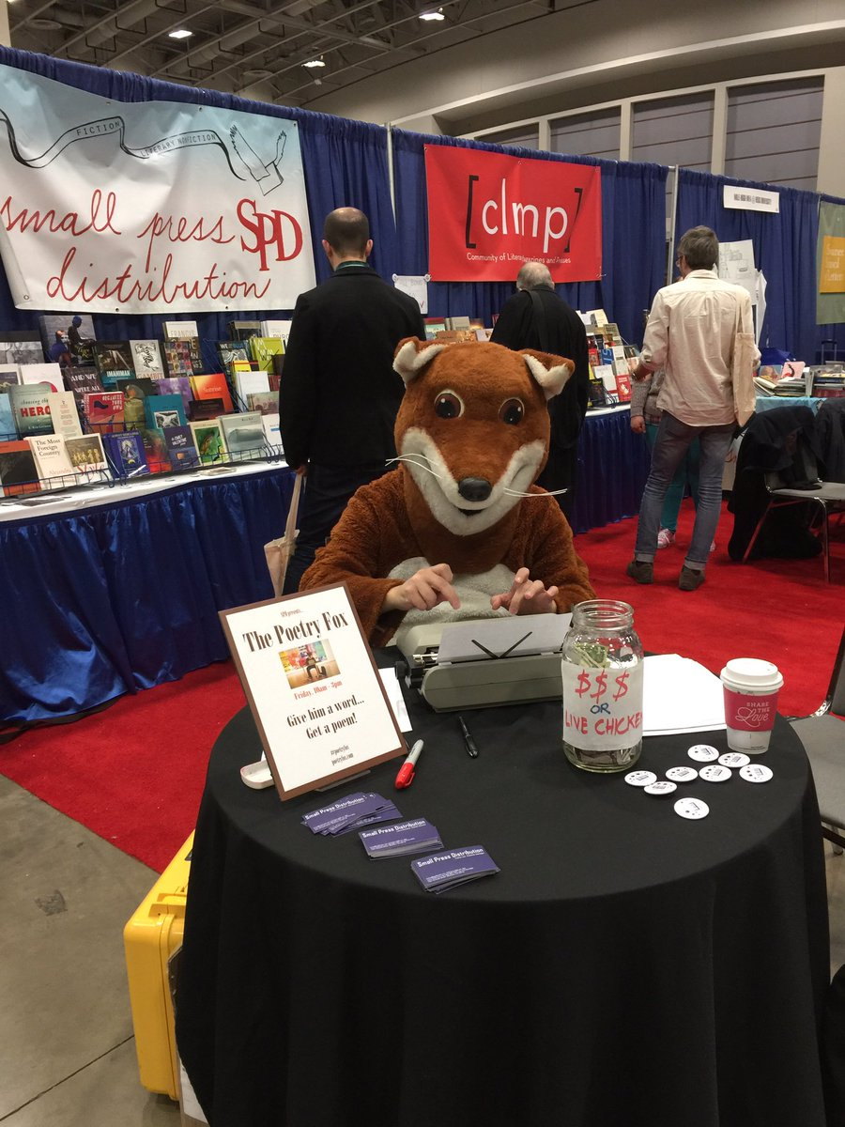
Claire Kirch‏@ClaireKirchMN
Loved @awpwriter had ASL ppl signing at @azarnafisi talk. Hope org can do that for all of the major speakers at future AWPs #tellAWP17.
Christian Teresi‏ @ChristianTeresi
@ClaireKirchMN We prioritize interpreters based on individual need. A lot of deaf attendees don't use ASL. #tellAWP17
Bottom of Form
Christian Teresi‏ @ChristianTeresi
@ClaireKirchMN Many deaf attendees use Cued Speech Transliteration or CART, & we prioritize the needs of those attendees. #tellAWP17.
Claire Kirch‏ @ClaireKirchMN
@ChristianTeresi Ohhh. wonder if you can do that, "subtitles," on the screens you have above the speakers? asking for a friend. #TellAWP17
Christian Teresi‏@ChristianTeresi
@ClaireKirchMN We are happy to take individualized CART (Communication Access Realtime Translation) requests. #TellAWP17

AWP‏ @awpwriter
@ClaireKirchMN @ChristianTeresi For future confs, if you (or a friend) needs accessibility services, contact us so we can make arrangements
Christian Teresi‏ @ChristianTeresi
@ClaireKirchMN We arrange interpreters based on the kind they need, & this makes it specific to what works best for them. #tellAWP17.
George's Dryad‏ @GeorgesDryad
@ChristianTeresi @ClaireKirchMN You need interpreters at the headline events. Please. Otherwise it's like you don't want us there.

Suzi G‏@SuziG
I hope future Caucus meetings are staggered since we contain multitudes. Would love to go to the Queer & the Latino Caucus for ex #TellAWP17
Christian Teresi‏ @ChristianTeresi
@SuziG The caucuses are allowed to pick their own schedule between Thurs, Friday, & Saturday. Those dates they picked themselves. #TellAWP17
Christian Teresi‏ @ChristianTeresi
@SuziG For #AWP18, they will be able to choose between two times on each day. 6 to 7:15 pm and 7:30 to 8:45 pm. #TellAWP17
Christian Teresi‏ @ChristianTeresi
@SuziG This should give the #AWP18 caucuses the space to spread out meeting if they choose. #TellAWP17
George's Dryad‏ @GeorgesDryad
@SuziG yes yes, we should not have to decide btw our identities. #TellAWP17

Cynthia Sherman‏@cshermanva
#tellawp17 Tweets for all at #AWP17
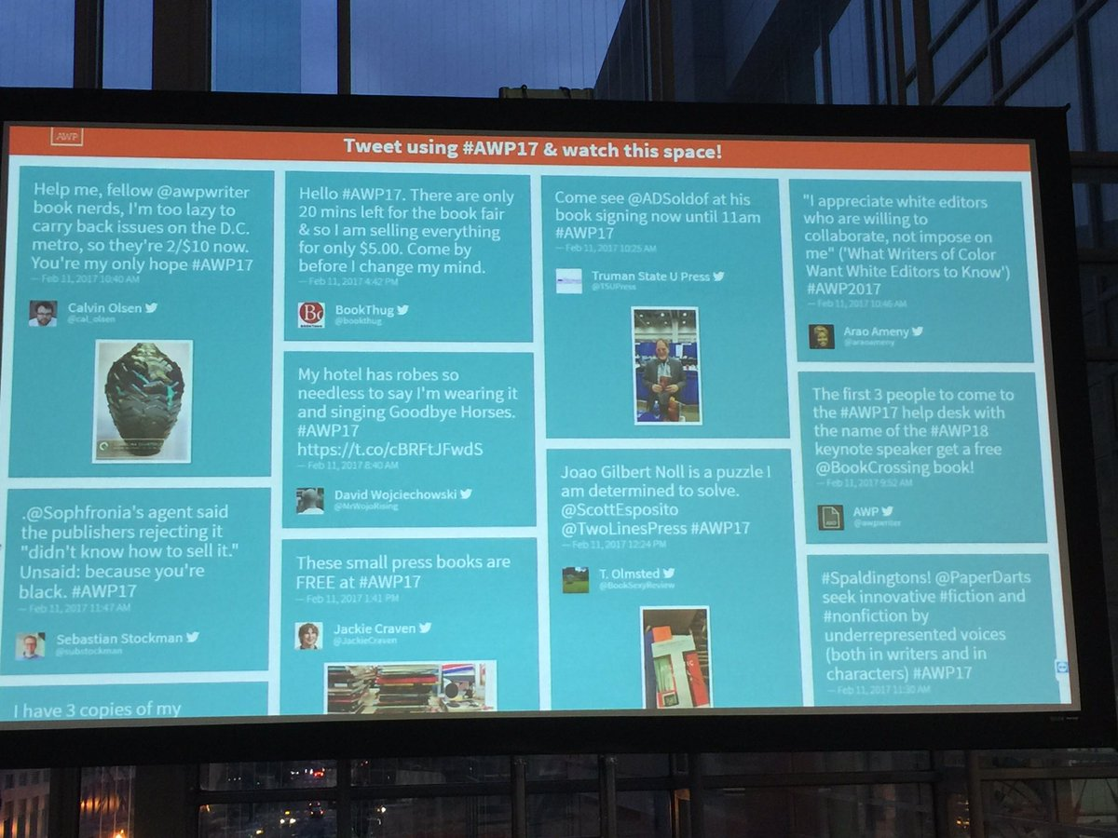

Christian Teresi‏@ChristianTeresi
What was your favorite #AWP17 event? What event fell short of your expectations? Any events give you ideas for future proposals? #TellAWP17
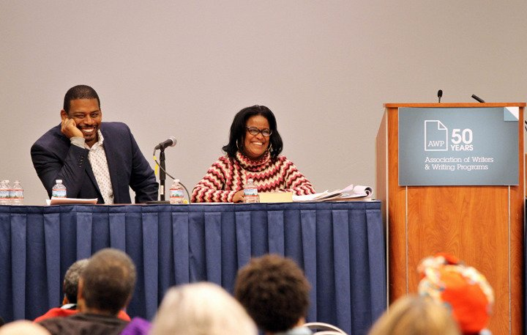
Jenee Darden‏@CocoaFly
@ChristianTeresi I loved Adichie and Coates but was disappointed that people were kept out when there were empty seats. #TellAWP17
Christian Teresi‏ @ChristianTeresi
I'm sorry to hear that @CocoaFly. The convention center pulled rank on us because they were so worried about the fire code.
Jenee Darden‏ @CocoaFly
@ChristianTeresi They were disorganized and shouldn't have set up so many seats if it was an issue. Luckily I got in.
Christian Teresi‏ @ChristianTeresi
@CocoaFly The huge crowd was the issue. The center was concerned about safety. We knew the crowd would be large but it exceeded expectations
Christian Teresi‏@ChristianTeresi
@CocoaFly I think the main ballroom was filled, & I know the center was actively working to fill empty seats in the overflow room.
Christian Teresi‏@ChristianTeresi
@CocoaFly We haven't see a crowd like that since Seamus Heaney & Derrick Walcott shared the stage in 2013.
Jenee Darden‏ @CocoaFly
@ChristianTeresi I heard there were some seats in the main room. I made it to overflow and there were plenty of seats.
Christian Teresi‏@ChristianTeresi
Thanks @CocoaFly. We asked people to hold up their hands if they had an empty seat next to them in the main room. Vast majority were filled.
George's Dryad‏@GeorgesDryad
#TellAWP17 @ChristianTeresi My favorite panel was I Sing the Body Queer & Crip. I wish it was easier to find #CripLit I almost missed it
Meg Day‏ @themegdaystory
@ChristianTeresi I loved the @AWPDisability Caucus, despite the stairs/door/extra agenda items we had to add last minute bc #ableism
Christian Teresi‏@ChristianTeresi
@themegdaystory And we appreciated the opportunity to discuss each of these concerns in depth with the @AWPDisability caucus. #TellAWP17
Christian Teresi‏@ChristianTeresi
@themegdaystory Feel free to contact me yourself to if you would like to have a larger discussion. I think you have my email. #TellAWP17

AWP‏@awpwriter
Which did you find most useful for the schedule: the digital app, the large printed program, the thin grid, or the website? #TellAWP17
Claire Kirch‏@ClaireKirchMN
Printed out my schedule from website 2 days b4 #AWP17, was perfect for my purposes #TellAWP17. Large printed program too big & heavy.
Robert J. Williams‏ @rwilliams69
@awpwriter #TellAWP17 Thin grid. Needed a few more posted around the conference venue, inside book fair, etc.
AWP‏ @awpwriter
@rwilliams69 More large schedule meter signs posted, you mean? Thanks!
Lisa Romeo‏@LisaRomeo
I agree with both points - thin grid was great AND if it were enlarged and posted in various locations, that would be helpful. #TellAWP17

AWP‏ @awpwriter
@LisaRomeo We did have some enlarged schedule signs for each day, but sounds like we needed more! Thanks!
Lisa Romeo‏ @LisaRomeo
@awpwriter Yes, because HUGE venue! #TellAWP17
Claire Kirch‏@ClaireKirchMN
@rwilliams69 @awpwriter Great idea, I looked for posted thin grids a few times. I left #AWP17 program in my hotel 15 mins. away #TellAWP17

Cathy Day‏ @daycathy
#TellAWP17 @awpwriter Big program isn't needed anymore. Most research the panels online in advance, only need thin grid or app at conference
Claire Kirch‏ @ClaireKirchMN
@daycathy @awpwriter I think the program is mostly for ad revenues -- and souvenir. Love the pics of previous AWPs.

Cathy Day‏ @daycathy
@ClaireKirchMN @awpwriter True. Those ads are important. I used to bring them home with me, but now, they are so heavy and I'm old. :-)
Lisa Romeo‏ @LisaRomeo
@awpwriter I like paper, but big book is cumbersome & heavy. I've seen (& liked) daily newsprint schedule at other conferences. #TellAWP17
Claire Kirch‏ @ClaireKirchMN
@LisaRomeo @awpwriter @PublishersWkly publishes daily newspaper at Book Expo ... just saying, just saying #tellAWP17.
Jenee Darden‏ @CocoaFly
@awpwriter The app and thin grid were most useful. #TellAWP17
Janna Marlies Maron‏ @justjanna
@awpwriter app!
Leslie Pietrzyk‏ @lesliepwriter
@awpwriter I always study the website & print out info...then I use the thin grid. Had a friend in love with the app!
the slimmest pug‏ @levicitodd
@awpwriter Definitely the website and app, i hated thinking how much paper the books were using.
Nanda Dyssou‏ @nandadyssou
@awpwriter The app, but it had a glitch. I couldn't rate the sessions. The ratings didn't show up.
Ms. Ellee‏ @wordwonk
@awpwriter loved and used the app and the thin grid.
John Williams‏ @Beard_a_Bull
@awpwriter the thin grid was the most popular
JB Blaine‏ @jbblaine
@awpwriter The printed program doesn't require charging one's batteries; a real pain finding an outlet between sessions.
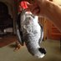Marisa PC‏ @Professor_Gaga
@awpwriter I used the website to plan and the print versions while I was there. #OldSchool
Write Despite‏ @write_despite
@awpwriter Most useful was Add to My Schedule option on website, which I printed out. Sync this to mobile app, and that would be the bomb.

Tiffany‏@AWPsTiffany
Feel free to #TellAWP17. Your registration experience is important to us.
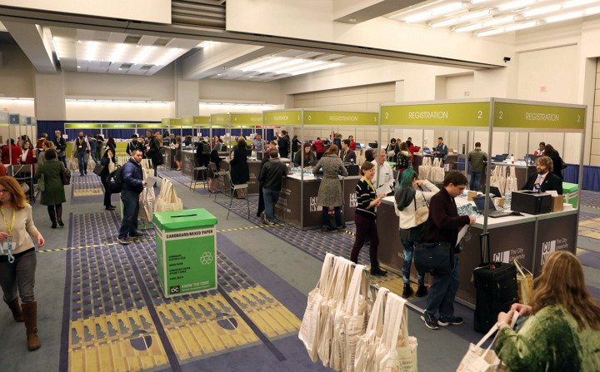

Tiffany‏@AWPsTiffany
How did you feel about the registration process? Is there anything different you would like for us to do? #TellAWP17
Lisa Romeo‏@LisaRomeo
@AWPsTiffany It was so quick and easy - I registered on site, couldn't remember my password, but it didn't matter. Kudos on that. #TellAWP17

Claire Kirch‏ @ClaireKirchMN
@AWPsTiffany Best registration process I've ever seen. Good job!
Tiffany‏ @AWPsTiffany
@ClaireKirchMN Thank you, that is fantastic to hear! Hope to see you in Tampa!
Claire Kirch‏ @ClaireKirchMN
@AWPsTiffany Believe me, me too! Tampa in March ... yes please!
Janna Marlies Maron‏ @justjanna
@AWPsTiffany @sukrungruang registration was very smooth for me. No complaints!
Colleen Cable‏@colleen_cable
Did you download the #AWP17 digital app? What was useful? What would you like to see changed? #tellawp17
Windy Lynn Harris‏ @WindyLynnHarris
@colleen_cable I was confused by the inbox. I didn't even know I had messages until I returned home. Was there a chime?
Colleen Cable‏ @colleen_cable
@WindyLynnHarris Any inbox message you have was originally sent as a push notification.
Windy Lynn Harris‏ @WindyLynnHarris
@colleen_cable Got it :)
Windy Lynn Harris‏ @WindyLynnHarris
@colleen_cable My favorite thing on the app was the My Schedule. Used that more than anything

Leanne Bowers‏ @larryspub
@colleen_cable SO useful! I loved that I could click on the location of an event and the map popped up with a marker cool! #tellawp17 #AWP17
Janna Marlies Maron‏ @justjanna
@larryspub @colleen_cable Agree. SUPER USEFUL! Love the note feature, too, to keep notes attached to events!
Cynthia Sherman‏@cshermanva
Any of your favorite BF exhibitors missing at #AWP17? Let me know and I will invite them to #AWP18 #TellAWP17
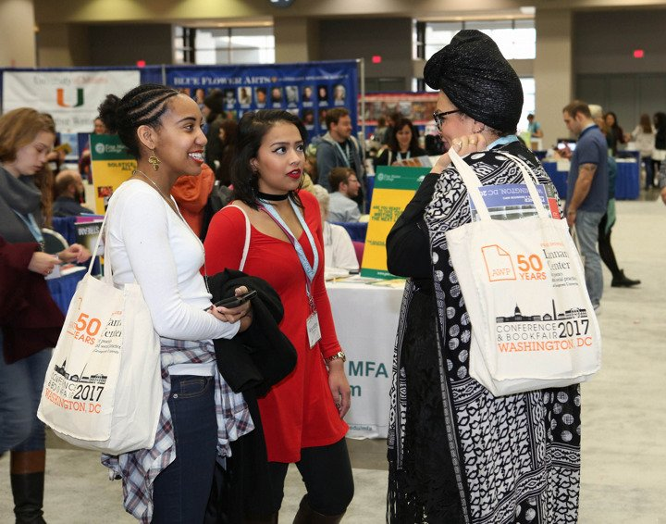
Claire Kirch‏ @ClaireKirchMN
Book Expo live streams its breakfast keynoters ... can #AWPwriter live stream major speakers, esp. evening keynoters #tellAWP17 ?
Christian Teresi‏@ChristianTeresi
Sorry @ClaireKirchMN we can't live stream. BEA has a lot more resources than we do. We're thinking about it for the future. #tellAWP17
George's Dryad‏ @GeorgesDryad
@ChristianTeresi @ClaireKirchMN If #BinderCon can livestream (and they can, and they do), then why can't you @awpwriter even if it's 1 event
Eloisa Amezcua‏@Eloisa_Amezcua
what if awp had 'scholarships' for indie litmags/presses to be a part of the bookfair...? #TellAWP17
AWP‏ @awpwriter
@Eloisa_Amezcua The winner of our small press publisher award does receive free exhibit space & registrations for the next conference.
Christian Teresi‏ @ChristianTeresi
@Eloisa_Amezcua We're definitely are working on this for the future. We don't have the staff to admin. such a program right now. #TellAWP17
Christian Teresi‏ @ChristianTeresi
@Eloisa_Amezcua But please feel free to nominate any lit mags or presses for the Small Press Award. #TellAWP17 https://www.awpwriter.org/contests/small_press_publisher_award_overview …
Cynthia Sherman‏ @cshermanva
@Eloisa_Amezcua We are working towards that goal! AWP recognizes importance of all work being represented. Thanks for writing! #TellAWP17

Christian Teresi‏@ChristianTeresi
Did @azarnafisi's #AWP17 keynote inspire you? #AWP18 Tampa event proposals will be accepted on March 7. The deadline is May 1. #TellAWP17
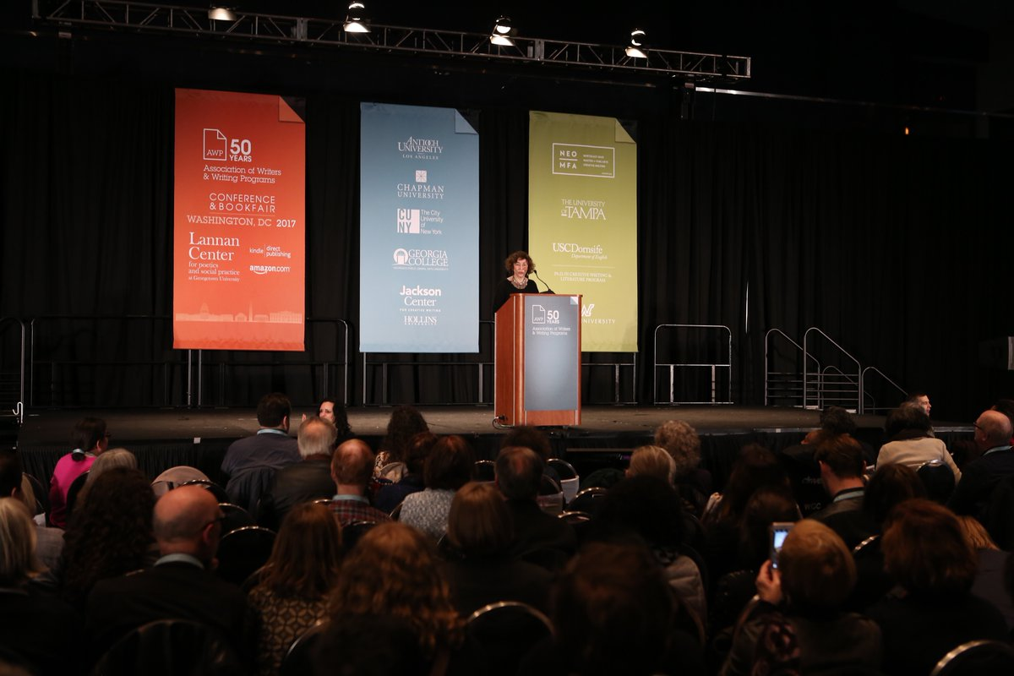
Claire Kirch‏@ClaireKirchMN
@ChristianTeresi @azarnafisi Hard to tell what the future will bring, but Azar Nafisi was perfect choice for #AWP17 #tellAWP17 #prescient.

Tiffany‏@AWPsTiffany
Feel free to share more of your thoughts by completing the survey #tellawp17 https://www.awpwriter.org/awp_conference/survey …
Cynthia Sherman‏@cshermanva
#AWP18 Bookfair sales open in June. We are really excited about being in Tampa! And look forward to seeing you there! #AWP17 #TellAWP17
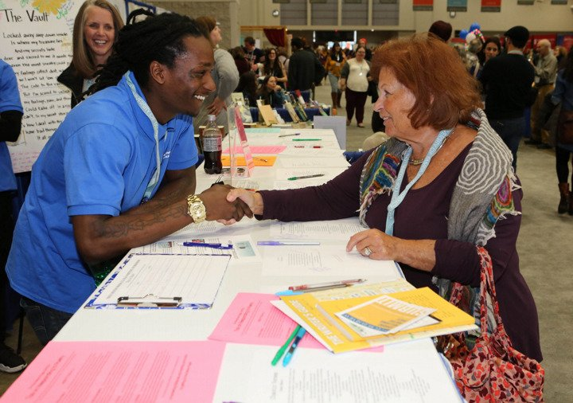 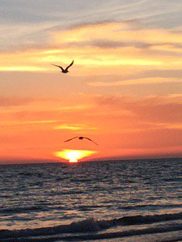

George's Dryad‏@GeorgesDryad
#TellAWP17 How come the automatic doors for disabled writers were broken throughout the conference?
Christian Teresi‏ @ChristianTeresi
@GeorgesDryad We welcome your criticism, but it's not possible to discuss all of this in 140 characters. Please email events@awpwriter.org.
George's Dryad‏ @GeorgesDryad
@ChristianTeresi Here's this Storify. Did you miss it? https://storify.com/GeorgesDryad/getting-started … #CripLit

George's Dryad‏@GeorgesDryad
#TellAWP17 We disabled writers are trying to understand where you're coming from. But we really don't get it @awpwriter
Christian Teresi‏ @ChristianTeresi
@GeorgesDryad There's a lot of information that would address your concerns, but it's really hard to discuss in 140 characters. #TellAWP17
Christian Teresi‏ @ChristianTeresi
@GeorgesDryad But to have a real conversation, one that allows us the best clarity, that would have to happen by email or phone.
Meg Day‏ @themegdaystory
@ChristianTeresi @GeorgesDryad Only one character needed! Make em d/Deaf or Disabled & give em a job as a liaison 4 #AWP18
Christian Teresi‏ @ChristianTeresi
@themegdaystory I agree it would help, and we're working on it and more. It's also not a magic bullet . . . #TellAWP17
Christian Teresi‏ @ChristianTeresi
@themegdaystory We're a new venue annually, which will present logistical issues for even the most seasoned accessibility events coordinator
George's Dryad‏ @GeorgesDryad
@ChristianTeresi Believe me. We have called you we have emailed you since 2014. This is not about our attempts. It's about yours.
Christian Teresi‏@ChristianTeresi
@GeorgesDryad Did you attend the conference? Would you like to have a personal conversation with me. We can make that happen.
Christian Teresi‏@ChristianTeresi
@GeorgesDryad I've had many conversations about accessibility and the conference, and it always always helps to have those by email or phone
Christian Teresi‏ @ChristianTeresi
@GeorgesDryad It's important for us to hear from attendees. Did you attend #AWP17? If so, we'd like to discuss accessibility in details.
George's Dryad‏ @GeorgesDryad
@ChristianTeresi Obviously, I attended.
Christian Teresi‏ @ChristianTeresi
@GeorgesDryad I ask because it's not uncommon for people to write about the conference without ever having attended. It's hard to tell.

Cynthia Sherman‏@cshermanva
#AWP17 #AWP18 Check AWP-Bookfair Facebook page for updates! https://www.facebook.com/awpbookfair #TellAWP17
George's Dryad‏@GeorgesDryad 33m33 minutes ago
#TellAWP17 Could you explain why the stages were inaccessible?
George's Dryad‏@GeorgesDryad
#TellAWP17 You accepted 20 of our panels. But then you made the buildings and stages inaccessible. @awpwriter @ChristianTeresi
George's Dryad‏@GeorgesDryad
#TellAWP17 Some of us were stuck in conference rooms because the doors were inaccessible and there were no attendants
George's Dryad‏@GeorgesDryad
#TellAWP17 & then we really wanted to be at the main readings, but there were no captions on the screens. And no interpreters.
George's Dryad‏@GeorgesDryad
#TellAWP17 Plz, plz hire a Disability and D/deaf Liaison. Okay, we would even settle for an ADA Coordinator. @awpwriter @ChristianTeresi
Christian Teresi‏ @ChristianTeresi
@GeorgesDryad That's one thing we're working on for #AWP18. We are constantly updating accessibility with updated best practices.
Ashley Strosnider‏@bravenewlady
One AWP-related idea: what if orgs with more free registrations than they need could donate them as "scholarship" registrations? #TellAWP17
Lisa Romeo‏@LisaRomeo
Great idea! #TellAWP17
Cynthia Sherman‏ @cshermanva
@bravenewlady We wrestle with this one every year and appreciate the idea of "scholarship" registrations. Thank you! #AWP17 #TellAWP17
Ashley Strosnider‏ @bravenewlady
@cshermanva Thanks for all you do!

Janna Marlies Maron‏@justjanna
Wifi continues to be an issue in the bookfair, it seems. @awpwriter #TellAWP17
George's Dryad‏@GeorgesDryad
#TellAWP17 you say "Let us know what you think." I think the conference is #ableist. Prove me wrong next year @awpwriter
George's Dryad‏@GeorgesDryad
#TellAWP17 I know you'll say "we're doing the best that we can." But it's simply not best not close to best not even bare minimum #ADA 1990
Janna Marlies Maron‏@justjanna
@awpwriter More distinct exhibitor badges would be useful, to alleviate traffic jam getting into bookfair before 9a. #TellAWP17
George's Dryad‏@GeorgesDryad
#TellAWP17 I know you'll say "we're doing the best that we can." But it's simply not best not close to best not even bare minimum #ADA 1990
George's Dryad‏@GeorgesDryad
#TellAWP17 What should I tell the disabled writers who don't want to come back? who don't think the conference is for them? @awpwriter
George's Dryad‏@GeorgesDryad
#TellAWP17 Should I tell them, again, like in 2014, 2015 and 2016, that you're working on it? @awpwriter @SFdirewolf

George's Dryad‏@GeorgesDryad
#TellAWP17 Do you even know about @monsteringmag @thedeafpoets @wordgathering & all the writers these mags bring to you?
George's Dryad‏@GeorgesDryad
#TellAWP17 If we can't enter the doors of the conference, then it's hard for us to feel happy about it. #PlzKnow
George's Dryad‏@GeorgesDryad
#TellAWP17 Plz check out #AccessibleOrganizingMeans and #CriptheVote and #CripLit
Jenee Darden‏@CocoaFly
@ChristianTeresi Some of the diversity, writers of color panels overlapped on the schedule. They should be spread out. #TellAWP17
Lisa Romeo‏ @LisaRomeo
@CocoaFly @ChristianTeresi Yes! Also happened w/genre topics - 4 panels on essay/ CNF/memoir at same time. #tellAWP17.

Christian Teresi‏@ChristianTeresi
@LisaRomeo We work very hard to spread similar events. There are so many events that overlapped its not always possible. #tellAWP17
Christian Teresi‏@ChristianTeresi
@LisaRomeo We also need to account for many schedule requests, AV requests, and presenters on more than one event. #tellAWP17
Christian Teresi‏ @ChristianTeresi
@LisaRomeo Making the schedule is the hardest thing we do all year. It's a priority to spread out similar events as much as possible.
Lisa Romeo‏ @LisaRomeo
@ChristianTeresi I'm sure it's an enormous headache w/lots of conflicting priorities! But you asked for feedback...
Christian Teresi‏ @ChristianTeresi
@CocoaFly Making the schedule is the hardest single thing we do all year, & it's a priority to spread out similar events as much as possible

Jenee Darden‏ @CocoaFly
@ChristianTeresi I can imagine it's hard!
Christian Teresi‏ @ChristianTeresi
@CocoaFly We work very hard to spread similar events out as much as possible.
Christian Teresi‏ @ChristianTeresi
@CocoaFly There were so many events that overlapped between multiculturalism, writers of color, and social justice that it was not possible.
Christian Teresi‏ @ChristianTeresi
@CocoaFly We also need to account for many schedule requests, AV requests, and presenters on more than one event.

George's Dryad‏@GeorgesDryad
Next time advertise this to caucuses #TellAWP17 @ChristianTeresi plz 4 the luv of the goddess
Christian Teresi‏ @ChristianTeresi
@GeorgesDryad We've been advertising this to everyone for several weeks. We haven't been shy about it.

George's Dryad‏@GeorgesDryad
#TellAWP17 I'm sorry I'm late. @awpwriter
AWP‏@awpwriter
Thank you all for participating in our #TellAWP17 chat and sharing your experiences.
AWP‏@awpwriter
If you have more #AWP17 feedback, please feel free to fill out this survey: https://www.awpwriter.org/awp_conference/survey … #TellAWP17
AWP‏@awpwriter
Please join us on 3/16 for #AWPWCC about our writer's conferences & centers programs and scholarship competition. #TellAWP17

