AWP’s Twenty-fifth Tweet Chat: #SubmitAWP18
April 4, 2017 from 4:00-5:00 p.m. ET

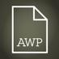AWP‏ @awpwriter
Learn how to put together a successful #AWP18 proposal today at 4pm ET! #SubmitAWP18 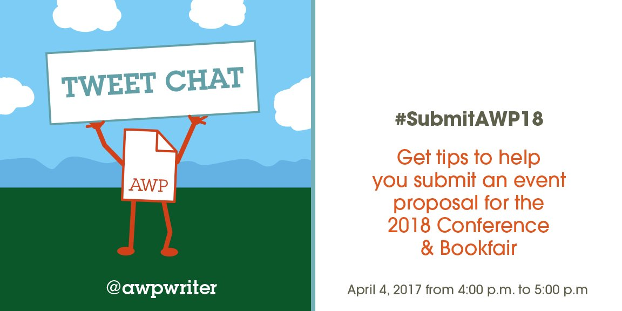
AWP‏ @awpwriter
Welcome to the #SubmitAWP18 tweet chat. Today we'll be discussing #AWP18 event proposals.
AWP‏ @awpwriter
To ask a question any time about conference event proposals, use #SubmitAWP18.

AWP‏ @awpwriter
With us today are @colleen_cable, Conference Events Coordinator, and @ChristianTeresi, Director of Conferences. #SubmitAWP18
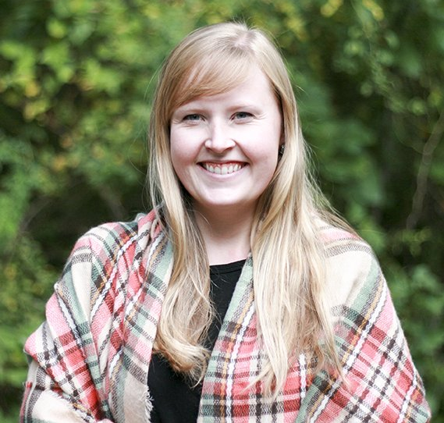 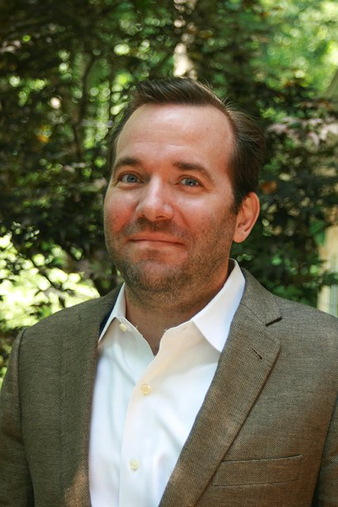
Christian Teresi‏ @ChristianTeresi
We'd love to answer any & all questions about #AWP18 event proposals. #SubmitAWP18
Colleen Cable‏ @colleen_cable
Is there a topic you’ve always wanted to see covered at AWP? Consider creating and submitting a proposal! #SubmitAWP18
Christian Teresi‏ @ChristianTeresi
Is a topic you want to see? Chances are other attendees do too. We're looking for as many kinds of literary events as possible. #SubmitAWP18

Christian Teresi‏ @ChristianTeresi
First time proposing an event? Or if you have made proposals in the past. Please review the guidelines #SubmitAWP18 https://www.awpwriter.org/awp_conference/event_proposals_overview …
Colleen Cable‏ @colleen_cable
The AWP Subcommittee is looking for events featuring those diverse in backgrounds, pursuits, affiliations, and ages #submitawp18
Ruth Spiro‏ @RuthSpiro
What's the best way for an author to get involved? Panel? Solo presentation? #submitawp18
Christian Teresi‏ @ChristianTeresi
Proposals must have at least 2 presenters & a maximum of 5. There is a wide range of literary subjects we're looking to cover. #SubmitAWP18
Christian Teresi‏ @ChristianTeresi
What interests you the most? Take a look at the categories events can be submitted under. #SubmitAWP18 https://www.awpwriter.org/awp_conference/event_proposals_guidelines#types …

Christian Teresi‏ @ChristianTeresi
#AWP18 Proposal Tip #1. Demonstrate how generous your proposal can be to a diverse & inclusive audience. #submitawp18
Colleen Cable‏ @colleen_cable
Have a proposal but not sure how to categorize it? Read about our categories here: https://www.awpwriter.org/awp_conference/event_proposals_guidelines#types … #submitawp18
Christian Teresi‏ @ChristianTeresi
#AWP18 Proposal Tip #2. Follow the guidelines carefully. You'd be surprised how many proposals ignored them & are turned down. #submitawp18
Christian Teresi‏ @ChristianTeresi
#AWP18 Proposal Tip #3. Be clear about what you are proposing. Descriptions should indicate topic as specifically as possible #submitawp18
Colleen Cable‏ @colleen_cable
Are you the Event Organizer? Moderator? Learn about these roles in our Presenter Guidelines #SubmitAWP18 https://www.awpwriter.org/awp_conference/event_proposals_presenter_guidelines …
Christian Teresi‏ @ChristianTeresi
#AWP18 Proposal Tip #4. Propose on subjects that you can demonstrate a degree of proficiency. This is a competitive process. #submitawp18
Christian Teresi‏ @ChristianTeresi
#AWP18 Proposal Tip #5. Keep in mind you are appealing to a group with wide-ranging literary interests. #submitawp18 https://www.awpwriter.org/awp_conference/event_proposals_subcommittees …
Colleen Cable‏ @colleen_cable
All participants must link their AWP user accounts to the event proposal #submitawp18
AWP‏ @awpwriter
Is there a date by which participants should be linked to their proposals? #SubmitAWP18
Colleen Cable‏ @colleen_cable
Proposals are due May 1st - all panelists must be linked by May 7 #submitawp18
Colleen Cable‏ @colleen_cable
Don't forget to include any audiovisual requests with your proposal! #submitawp18
Christian Teresi‏ @ChristianTeresi
#AWP18 Proposal Tip #7. Make sure your panelists link to the proposal. Otherwise, their bio will be absent from proposal. #submitawp18
Anna Leahy‏ @GenerationSpace
This is an important logistical step. Missing proposal parts doesn't bode well. Chose reliable panelists. #AWP18 #submitAWP18

Christian Teresi‏ @ChristianTeresi
#AWP18 Proposal Tip #8. A lot of proposals are rejected because panelists fail to link their account to the proposal. #submitawp18
Colleen Cable‏ @colleen_cable
Unsure how to submit an event? Here’s a short video that will walk you through the process. #submitawp18
Christian Teresi‏ @ChristianTeresi
#AWP18 Proposal Tip #9. Original programming will work to your benefit. Most proposals are

Christian Teresi‏ @ChristianTeresi
#AWP18 Proposal Tip #10. Ask: How does the proposal add new, under appreciated or under recognized information to conversation? #submitawp18
Christian Teresi‏ @ChristianTeresi
#AWP18 Proposal Tip #11. Ask: How does this proposal speak beyond my own concerns to a larger audience? #submitawp18
Christian Teresi‏ @ChristianTeresi
#AWP18 Proposal Tip #12. Ask: How does the proposal speak to views I may not share or even agree with, but other writers may? #submitawp18
AWP‏ @awpwriter
Have a question about #AWP18 event proposals? Ask our conference staff now by using #submitawp18
Colleen Cable‏ @colleen_cable
Remember the limits on participation - you may be a participant in no more than three #AWP18 proposals. #submitawp18

Christian Teresi‏ @ChristianTeresi
#AWP18 Proposal Tip #13. Ask: How do I represent as many different (even opposing) views as possible on this literary subject? #submitawp18
Christian Teresi‏ @ChristianTeresi
#AWP18 Proposal Tip #14. Look at the criteria for evaluation; they will give you an idea how the proposals are judged. #submitawp18
Christian Teresi‏ @ChristianTeresi
#AWP18 Proposal Tip #15. Take a look at the information for how events are selected. #submitawp18 https://www.awpwriter.org/awp_conference/event_proposals_selection …
Colleen Cable‏ @colleen_cable
Check out who is on #AWP18's Tampa subcommittee! #submitawp18 https://www.awpwriter.org/awp_conference/event_proposals_subcommittees …
Christian Teresi‏ @ChristianTeresi
#AWP18 Proposal Tip #16. Do not wait until the last minute to submit your proposal. Begin the process of crafting it ASAP. #submitawp18

AWP‏ @awpwriter
You can save unfinished proposals in our system and come back to work on them another time. #SubmitAWP18

Colleen Cable‏ @colleen_cable
If you have already submitted a proposal, but need to make a change, email events@awpwriter.org #submitawp18
AWP‏ @awpwriter
Thank you for joining us today for #SubmitAWP18. For more information, check out: https://www.awpwriter.org/awp_conference/event_proposals_overview …

