AWP’s Third Tweet Chat: Behind the Scenes at AWP’s Office
May 6 from 3:00-4:00 p.m. ET
AWP ‏@awpwriter May 5
Join us tomorrow, 5/6, from 3-4pmET for our next Tweet Chat and learn about AWP's offices, staff, & services! #BTSAWP
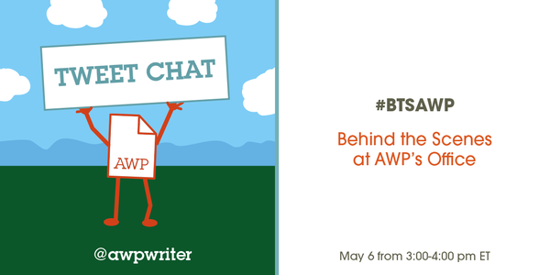
AWP ‏@awpwriter 6h6 hours ago
Did you know @GeorgeMasonU has been AWP's host university since 1994? Learn more today at #BTSAWP 3-4pm ET
AWP ‏@awpwriter 2h2 hours ago
Welcome to AWP's third Tweet Chat: a behind the scenes look at AWP! #BTSAWP
AWP ‏@awpwriter 2h2 hours ago
We'll be sharing fun facts and photos about AWP's offices, staff, and services. #BTSAWP
AWP ‏@awpwriter 2h2 hours ago
With us for the next hour is @donaldgarrett, Development Assistant at AWP. #BTSAWP
AWP ‏@awpwriter 2h2 hours ago
Ask a question about AWP & follow the chat by using the hashtag #BTSAWP
Donald Garrett ‏@DonaldGarrett 2h2 hours ago
I'm excited to be tweeting to our amazing @awpwriter members! #BTSAWP
Donald Garrett ‏@DonaldGarrett 1h1 hour ago
Hi everyone! So to introduce myself, I'm Donald and I've been with AWP since Sept 2014. I work with development/fundraising #BTSAWP
Donald Garrett ‏@DonaldGarrett 1h1 hour ago
AWP’s offices are in an old residential house purchased by GMU. #BTSAWP @awpwriter
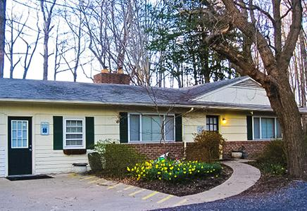
Dana Craig ‏@danalcraig
@DonaldGarrett @awpwriter Cool!
Donald Garrett ‏@DonaldGarrett 53m53 minutes ago
Donald Garrett retweeted Dana Craig
A lot of magic happens in this cottage in the woods #BTSAWP #awp
Dana Craig ‏@danalcraig 52m52 minutes ago
@DonaldGarrett That sounds a bit ominous... #BTSAWP

Donald Garrett ‏@DonaldGarrett 1h1 hour ago
It's called Carty House after the family that used to own the land. #BTSAWP
Donald Garrett ‏@DonaldGarrett 1h1 hour ago
Carty House is nice because it's in a quiet area compared to the surrounding Fairfax, VA/ DC area. We're even visited by critters! #BTSAWP
Leanne Molter ‏@larryspub 1h1 hour ago
.@DonaldGarrett @awpwriter I feel like we need a Snow White joke at the end. #BTSAWP
Cynthia Sherman ‏@cshermanva 58m58 minutes ago
Behind the scenes at AWP chat. This is where all the magic is made!#BTSAWP

EDML ‏@exclamate_ 1h1 hour ago
@awpwriter What's the most exciting thing about working at AWP? #BTSAWP
AWP ‏@awpwriter 1h1 hour ago
.@exclamate_ For me (webmaster) it's being surrounded by the the literary world. I find it inspiring to work with & for writers! #BTSAWP
Donald Garrett ‏@DonaldGarrett 1h1 hour ago
Everything! The members and staff are so warm and welcoming. I like serving a creative community #BTSAWP
Kelley McLain ‏@kelleylou6 1h1 hour ago
@exclamate_ @awpwriter For me it's not knowing who I will be interacting with next.. So many great writers are active AWP members! #BTSAWP
Sarah Katz ‏@sarahbea89 1h1 hour ago
@exclamate_ @awpwriter For me, it's being surrounded by a cadre of ambitious writers, readers, and literary citizens! #BTSAWP
Sarah Katz ‏@sarahbea89 41m41 minutes ago
@exclamate_ @awpwriter I should add that I love poring through the stack of poetry collections sent to AWP for Books by Members. #BTSAWP
Cristina ‏@CristinaEstell1 1h1 hour ago
@DonaldGarrett For me, it's being surrounded by so many uniquely awesome coworkers! #BTSAWP
Leanne Molter ‏@larryspub 1h1 hour ago
.@exclamate_ @awpwriter For me (Designer) it's the awesome opportunity to draw illustrations and be in a more creative environment. #BTSAWP
EDML ‏@exclamate_
@larryspub @awpwriter Like the little AWP page guy who reminds me to do things in a timely fashion!?
AWP ‏@awpwriter 59m59 minutes ago
@exclamate_ @larryspub Did you know he has a name? His name is Dogear! #BTSAWP
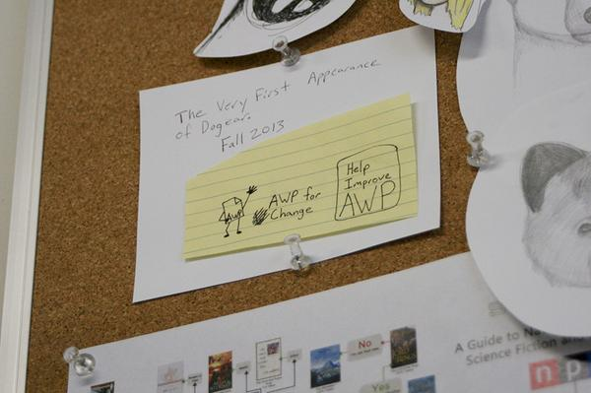
EDML ‏@exclamate_
@larryspub @awpwriter I did NOT know that, but I loooove that guy!

Donald Garrett ‏@DonaldGarrett 1h1 hour ago
Here's some friends that've visited us at Carty House #BTSAWP @awpwriter
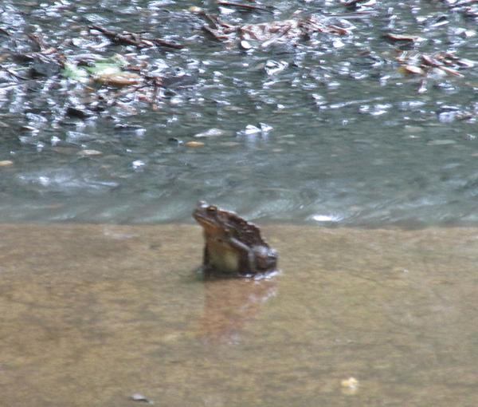
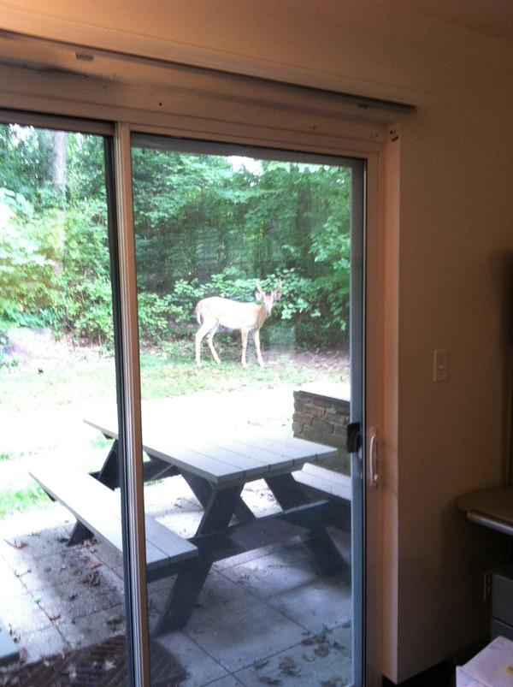
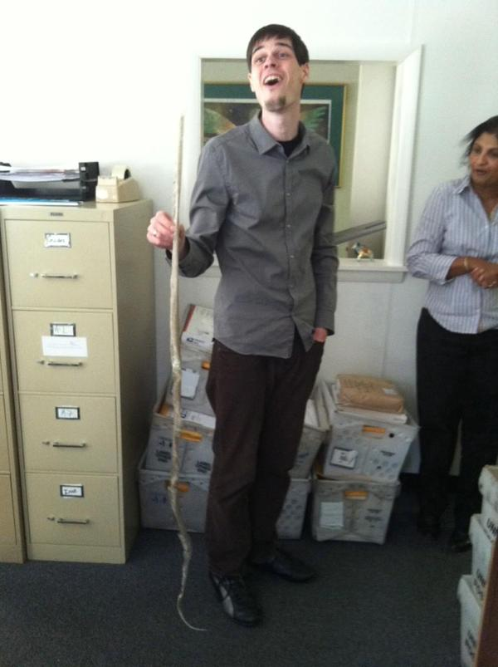
Kelley McLain ‏@kelleylou6 1h1 hour ago
@DonaldGarrett @awpwriter Glad I wasn't here when that snake skin was found in the basement!! #BTSAWP

Donald Garrett ‏@DonaldGarrett 1h1 hour ago
Since this is supposed to be a behind the scenes look, I will start in the basement (where I work) and work my way through the house #BTSAWP
Donald Garrett ‏@DonaldGarrett 1h1 hour ago
.@cshermanva (yogi-in-residence) and I share an office downstairs #BTSAWP @awpwriter
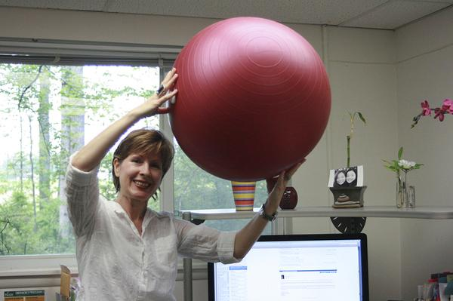
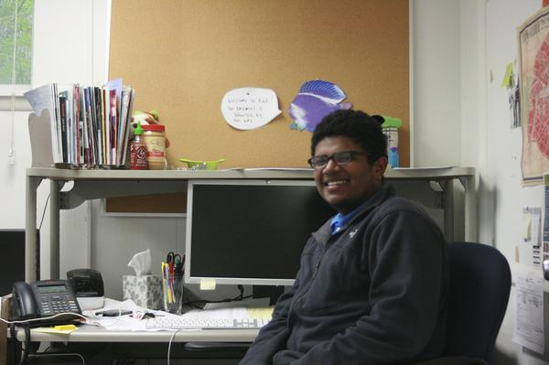
Donald Garrett ‏@DonaldGarrett 1h1 hour ago
These decorations were left when I got here #shrug #BTSAWP

Donald Garrett ‏@DonaldGarrett 1h1 hour ago
Our conference team is in the basement of Carty House #AWP #BTSAWP
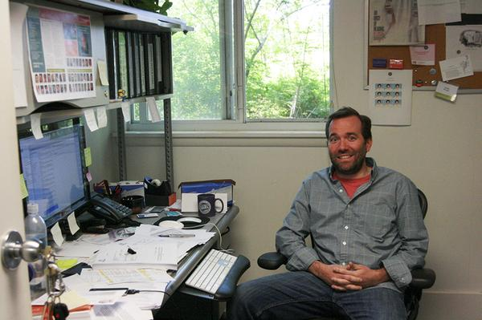
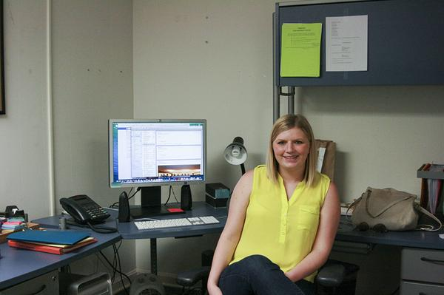

Donald Garrett ‏@DonaldGarrett 1h1 hour ago
These stairs lead to everyone else! #BTSAWP
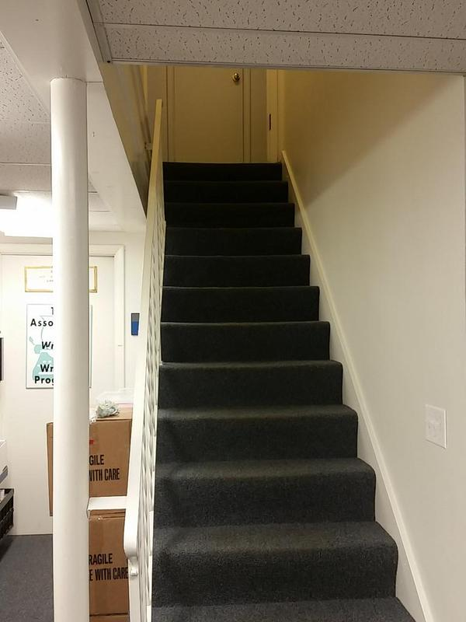
Dana Craig ‏@danalcraig 50m50 minutes ago
Are the stairs part of the corporate wellness program? ;) @DonaldGarrett #BTSAWP
AWP ‏@awpwriter 48m48 minutes ago
@danalcraig @DonaldGarrett LOL! So are the days when we get Chronicles delivered and we all carry them downstairs one box at a time #BTSAWP
Dana Craig ‏@danalcraig 46m46 minutes ago
@awpwriter @DonaldGarrett A well-balance program! Good job. #BTSAWP
Leanne Molter ‏@larryspub
@awpwriter @danalcraig @DonaldGarrett Yep! The Chronicles are our bi-monthly calisthenics program!

Donald Garrett ‏@DonaldGarrett 1h1 hour ago
The conference relies on the expertise of all staff, but the conference team itself consists of only 4 people #BTSAWP
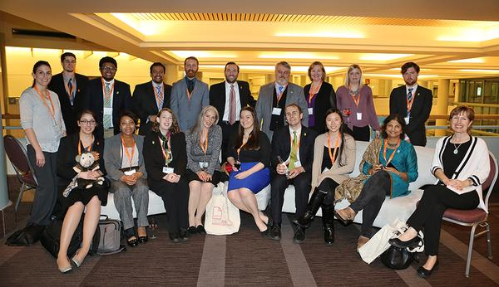
AWP ‏@awpwriter 1h1 hour ago
There's the hard-working team that brought you #AWP15! #BTSAWP

Donald Garrett ‏@DonaldGarrett 60m60 minutes ago
Brittany, Kenny, & [unpictured] Taylor work by the front door of Carty house. They work with Membership #BTSAWP
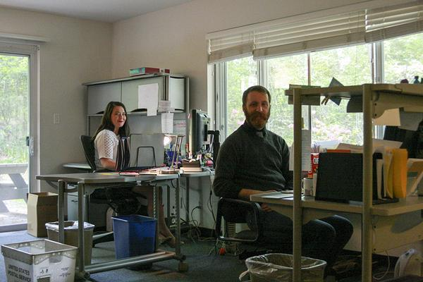
Donald Garrett ‏@DonaldGarrett 58m58 minutes ago
The 3 of them sort all mail to AWP, answer all phone calls to our main line, & respond to all emails to awp@awpwriter.org #BTSAWP

Donald Garrett ‏@DonaldGarrett 54m54 minutes ago
Membership Director @DianeZinna showcases her adorable daughter's artwork! #BTSAWP (I have an original piece as well)
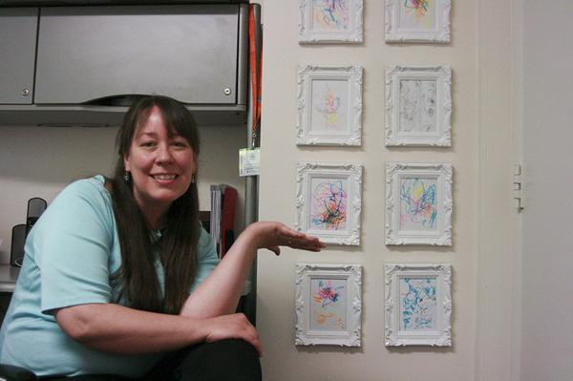

Donald Garrett ‏@DonaldGarrett 51m51 minutes ago
Also upstairs, Our accounting "department" is just 1 person! #BTSAWP
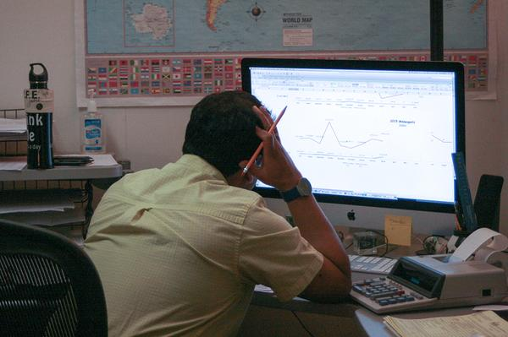

Donald Garrett ‏@DonaldGarrett 45m45 minutes ago
Pamela (my supervisor) and THE David Fenza are also upstairs #BTSAWP
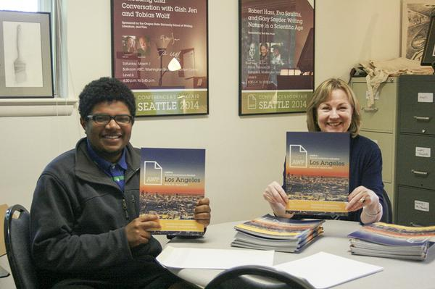
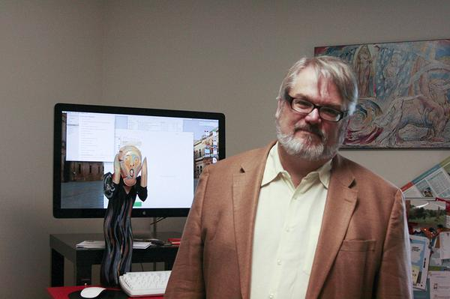
AWP ‏@awpwriter 42m42 minutes ago
.@david_AWP's Scream statue there was a gift from AWP staff members in 1995, his first year as Executive Director #BTSAWP
Dana Craig ‏@danalcraig 41m41 minutes ago
.@awpwriter @david_AWP Just noticed that in the background! Nice to see that Exec Directors have a healthy sense of humor! #BTSAWP
Donald Garrett ‏@DonaldGarrett 41m41 minutes ago
The last portion of Carty House is an added attachment (I think?). It houses Publications and Web Services/IT #BTSAWP
Leanne Molter ‏@larryspub 39m39 minutes ago
@DonaldGarrett Used to be the car port, which is why our advertising manager has a door bell in her office. #BTSAWP
AWP ‏@awpwriter 37m37 minutes ago
Yep! @larryspub And one inside wall of the webmaster's office is literally the original siding of the house #BTSAWP
AWP ‏@awpwriter 40m40 minutes ago
Fun fact: when we have storms, sometimes our power flickers. We just experienced that here a second ago, but we're still here! #BTSAWP
Donald Garrett ‏@DonaldGarrett 38m38 minutes ago
The Publications Team (minus @larryspub because Twitter only let me upload 4 pics) #BTSAWP @awpwriter
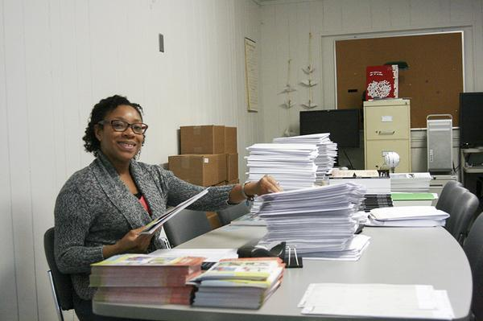
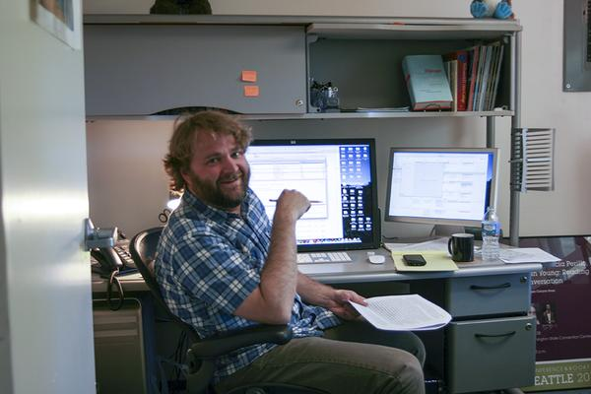
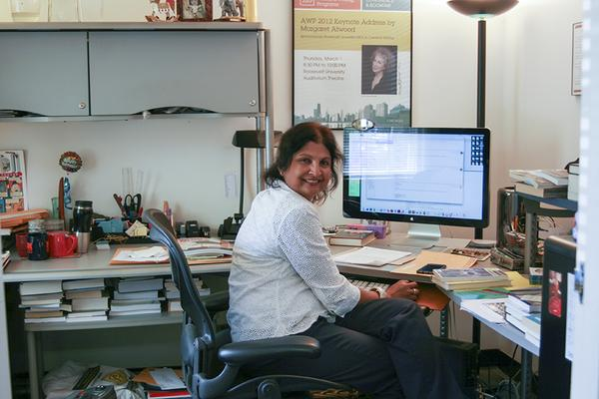
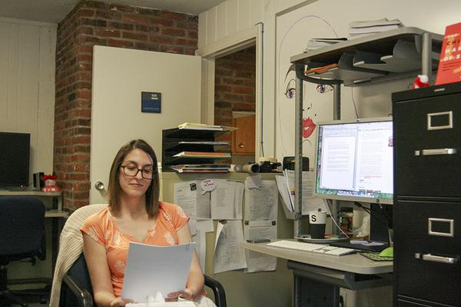

Donald Garrett ‏@DonaldGarrett 36m36 minutes ago
.@larryspub and Web Services/IT! #BTSAWP
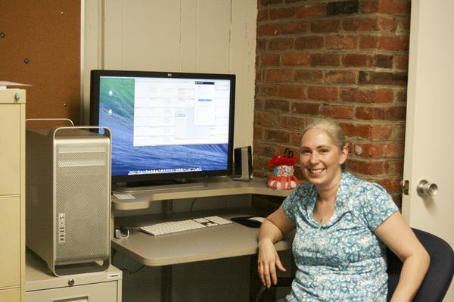
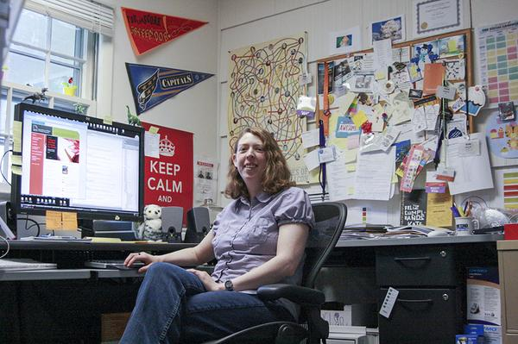
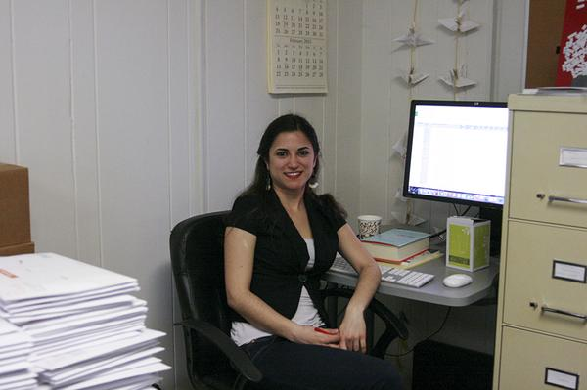
Donald Garrett ‏@DonaldGarrett 35m35 minutes ago
Our "break room" / kitchen and mail room #BTSAWP
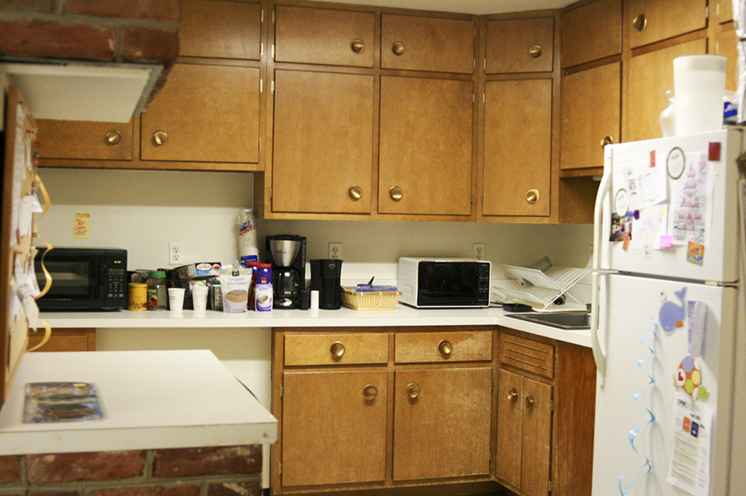
Donald Garrett ‏@DonaldGarrett 34m34 minutes ago
Christina, our newest employee, started 2 days ago! I felt so welcomed when I walked into this on my 1st day #BTSAWP
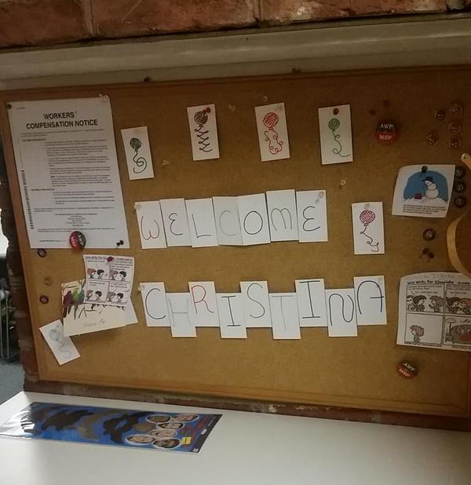
Dana Craig ‏@danalcraig 31m31 minutes ago
.@DonaldGarrett That's a great tradition! Thanks for sharing your work space with us. Nice break in the day. #BTSAWP
AWP ‏@awpwriter 29m29 minutes ago
@danalcraig @DonaldGarrett The letters are re-purposed business cards from before we changed logos! We don't waste anything #BTSAWP
Leanne Molter ‏@larryspub 22h22 hours ago
@awpwriter @danalcraig Very true I use our old not usable stationary to write/send letters to my grandmother. She's impressed by nice paper.
Donald Garrett ‏@DonaldGarrett 33m33 minutes ago
The images we've shared today can be seen on our new Behind the Scenes Pinterest board: https://www.pinterest.com/awpwriter/behind-the-scenes-at-awp/ #BTSAWP
Donald Garrett ‏@DonaldGarrett 31m31 minutes ago
Third time in a row I forgot to put up @larryspub's picture! #BTSAWP
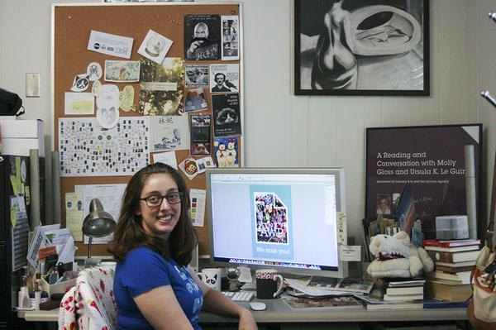

Donald Garrett ‏@DonaldGarrett 27m27 minutes ago
Does anyone have any other questions? Did you enjoy the virtual office tour?? #BTSAWP @awpwriter
Donald Garrett ‏@DonaldGarrett 17m17 minutes ago
I had fun giving you a behind the scenes look at our office! #KeepCalmAndTweetOn #BTSAWP @awpwriter
AWP ‏@awpwriter 15m15 minutes ago
Thanks so much for joining us on our look behind the scenes at AWP! June's Tweet Chat will be about the bookfair with @cshermanva! #BTSAWP

