AWP’s Seventh Tweet Chat:
the George Garrett Award & the Small Press Publisher Award
September 10, 2015 from 2:00-3:00 p.m. ET

AWP ‏@awpwriter
In half an hour, we'll answer your questions re: the George Garrett & Small Press Publisher awards. Use #AWPawards.
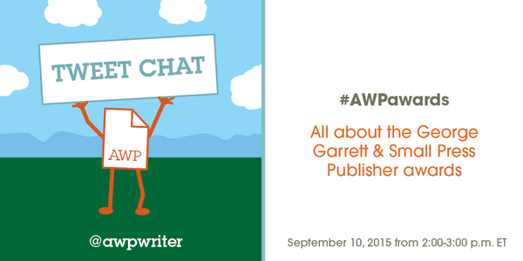
AWP ‏@awpwriter
Welcome to AWP's 7th tweet chat. Today we'll be discussing two of AWP's awards: the George Garrett & the Small Press Publisher. #AWPawards
AWP ‏@awpwriter
With us today are Christian Teresi @ChristianTeresi, Director of Conferences, and David Fenza @david_AWP, Executive Director. #AWPawards
AWP ‏@awpwriter
To ask a question during the next hour about these two awards, use hashtag #AWPawards.
David Fenza ‏@david_AWP
AWP George Garrett Award recognizes leading teachers, mentors, editors, administrators, & community builders in literature. #AWPawards
Christian Teresi ‏@ChristianTeresi
AWP’s Small Press Publisher Award is an annual prize for nonprofit presses and literary journals. #AWPawards @awpwriter
Christian Teresi ‏@ChristianTeresi
The Small Press Award recognizes the role presses and journals play in publishing creative works and introducing new authors. #AWPawards
David Fenza ‏@david_AWP
George Garrett 1929-2008 was one of the founding trustees of AWP. #AWPawards
David Fenza ‏@david_AWP
As a teacher, editor, mentor, trustee, & friend, George helped many authors establish their careers. #AWPawards

AWP ‏@awpwriter
George Garrett, for whom the award is named. #AWPawards
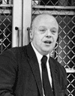
Christian Teresi ‏@ChristianTeresi
The Small Press Award was started in 2013, and has recognized the great work of @sarabandebooks, @onestorymag, & @GraywolfPress. #AWPawards
Christian Teresi ‏@ChristianTeresi 54m54 minutes ago
In even years, the Small Press Award is given to a journal, and, in odd years, to a press. #AWPawards
David Fenza ‏@david_AWP
Garrett Award includes $2,000 & expense-paid trip to AWP conference. #AWPawards
David Fenza ‏@david_AWP
AWP established the Garrett Award in 2005 to honor the many literary movers and shakers in the service of literature. #AWPawards

Christian Teresi ‏@ChristianTeresi
The 2016 Small Press Publisher Award winner will receive a $2,000 honorarium and a complimentary exhibit booth at #AWP17 in Washington, DC. #AWPawards
David Fenza ‏@david_AWP
AWP confers the Garrett & Small Press Awards at the awards reception Wednesday night of the conference. #AWPawards
David Fenza ‏@david_AWP 50m50 minutes ago
Emcees for last year’s award ceremonies were AWP Board Chair Bonnie Culver & novelist Marlon Jamees. #AWPawards
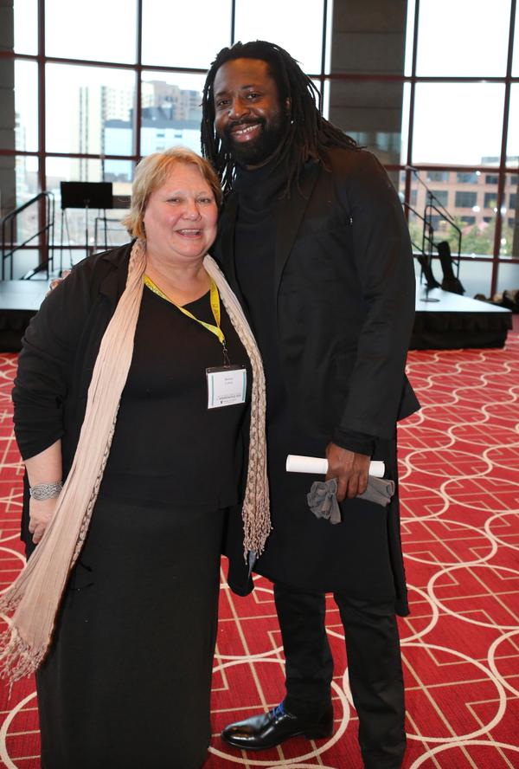

David Fenza ‏@david_AWP
The last awards reception featured entertainment by Cornelius Eady & Rough Magic. #AWPawards
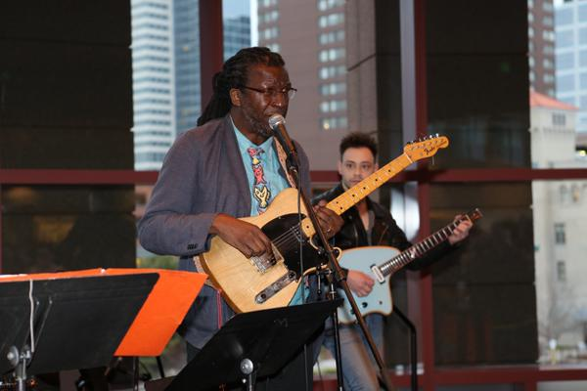

Christian Teresi ‏@ChristianTeresi
Nominations for literary journals and magazines are now being accepted for the 2016 Small Press Award. Deadline: September 15. #AWPawards
Christian Teresi ‏@ChristianTeresi
Here are the guidelines for nominations for the 2016 Small Press Publisher Award on @awpwriter website. #AWPawards https://www.awpwriter.org/application/public/pdf/awards/AWP_Small_Press_Publisher_Award_Guidelines.pdf …
David Fenza ‏@david_AWP
The deadline for letters of nomination for Garrett Award is also Sept. 15. #AWPawards
David Fenza ‏@david_AWP
Garrett Award guidelines https://www.awpwriter.org/application/public/pdf/awards/AWP_Garrett_Award_Guidelines.pdf … #AWPawards

AWP ‏@awpwriter
You can find information about the George Garrett award, including guidelines & previous winners, here: https://www.awpwriter.org/contests/george_garrett_award_overview … #AWPawards
AWP ‏@awpwriter
For more information about the Small Press Publisher Award, including previous winners, check out: https://www.awpwriter.org/contests/small_press_publisher_award_overview … #AWPawards

Christian Teresi ‏@ChristianTeresi
Here is the awesome staff @GraywolfPress receiving the 2015 Small Press Award at #AWP15 in Mpls. #AWPawards
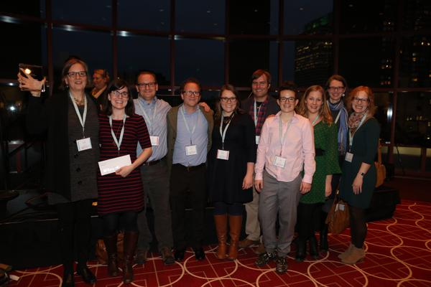

David Fenza ‏@david_AWP
You can find the list of past Garrett winners on our website https://www.awpwriter.org/contests/george_garrett_award_previous_winners/2005 … #AWPawards
AWP ‏@awpwriter
You can submit nominations using AWP's new @submittable portal: https://awp.submittable.com/submit #AWPawards

David Fenza ‏@david_AWP 40m40 minutes ago
Novelist & esteemed teacher Bob Shacochis was last year’s Garett Award winner. https://www.awpwriter.org/contests/george_garrett_award_previous_winners/2015 … #AWPawards
Christian Teresi ‏@ChristianTeresi
Small Press Publisher Prize nominations will be considered for three years, including the year the nomination is submitted. #AWPawards
EDML ‏@exclamate_
@ChristianTeresi @awpwriter #awpawards: Perhaps a boring technical question, but why must they be nonprofits? Credibility?
Christian Teresi ‏@ChristianTeresi
AWP wanted to recognize the very important role nonprofit literary presses and journals play in the community. @exclamate_ #AWPawards
David Fenza ‏@david_AWP
@exclamate_ @ChristianTeresi @awpwriter Many small presses are labors of love. They need & deserve special loving support.

David Fenza ‏@david_AWP
Garrett Award nomination letters also remain in active consideration for 3 years. No need to resubmit each year. #AWPawards
David Fenza ‏@david_AWP
The best Garrett nomination letters are specific, personal—how the nominee helped you and your community. #AWPawards
David Fenza ‏@david_AWP
The best Garrett nomination letters also address the criteria of the award. See guidelines on website. #AWPawards
Christian Teresi ‏@ChristianTeresi
Small Press nominations should include explanation of how the journal contributed to the literary landscape & nurtured authors. #AWPawards
David Fenza ‏@david_AWP
AWP receives 20 or more letters supporting the typical Garrett award recipient—a community speaks on behalf of the nominee. #AWPawards
Christian Teresi ‏@ChristianTeresi
AWP usually receives between 10 and 15 nominations for the Small Press Publisher Prize. #AWPawards
Christian Teresi ‏@ChristianTeresi
Each Small Press Publisher nomination includes between 2 and 10 letters from writers and editors supporting the nominee. #AWPawards
EDML ‏@exclamate_
@david_AWP @awpwriter #awpawards Fenza, you've been around for awhile. Did you know George? What was he like?
David Fenza ‏@david_AWP
@exclamate_ @awpwriter I did know George. He was a huge help to AWP. He edited our Intro anthologies for many years.
David Fenza ‏@david_AWP
@exclamate_ @awpwriter He gave many of AWP's graduates their first national publication. His historical novel, Death of the Fox, is fine.
David Fenza ‏@david_AWP
@exclamate_ @awpwriter George was warm and funny. Dick Bausch honored George at our offices years ago at a small tribute. Much laughter.

AWP ‏@awpwriter
Any last questions about these awards? Remember the application deadline is September 15! #AWPawards
AWP ‏@awpwriter
Any final thoughts to share about these #AWPawards, @ChristianTeresi & @david_AWP?
David Fenza ‏@david_AWP
These awards are partly made possible through AWP members' donations to the AWP Services Endowment. Thank you for your support. #AWPawards
Christian Teresi ‏@ChristianTeresi
5 days left to nominate (& encourage nominations) your favorite literary journal #AWPawards https://www.awpwriter.org/contests/small_press_publisher_award_overview …
AWP ‏@awpwriter
We love seeing journals getting the word out to their readers & followers about the Small Press Publisher award! #AWPawards
David Fenza ‏@david_AWP
Reading these letters is heart-warming--a tribute to the health of contemporary literature & the spirits who make it so fruitful. #AWPawards
AWP ‏@awpwriter
We look forward to all of your nominations. #AWPAwards
AWP ‏@awpwriter
Thank you for joining us today to learn about #AWPawards. Our next chat will be Oct. 7 about #AWP16 registration.
