AWP’s Seventeenth Tweet Chat: #AWPWebsite
June 9, 2016 from 3:00-4:00 p.m. ET

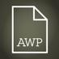AWP ‏@awpwriter
Discover new-to-you pages in the #AWPwebsite today at 3:00 p.m.
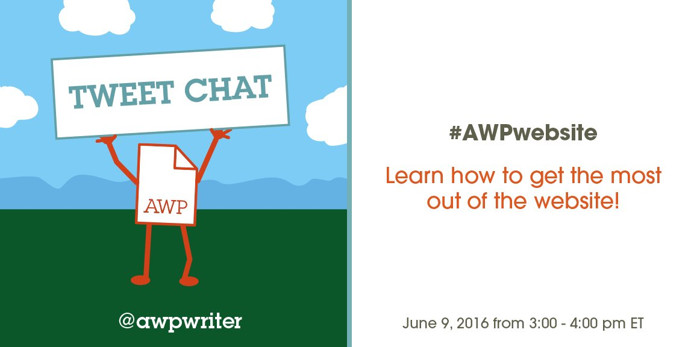
AWP ‏@awpwriter
In one hour, join us for a tour of AWP's site using #AWPwebsite. Learn tricks & ask questions!
AWP ‏@awpwriter
So glad you could join us for a look at the #AWPwebsite. For the next hour, we'll look at different features & sections of the site.

AWP ‏@awpwriter
With you today is AWP's webmaster of 10 years, Kate McDevitt, @kate_bookworm. #AWPwebsite
AWP ‏@awpwriter
To ask a question about the website at any time, use #AWPwebsite.
Kate McDevitt ‏@kate_bookworm
Thanks for your interest in the #AWPwebsite! http://awpwriter.org
Kate McDevitt ‏@kate_bookworm
I’ve been AWP's webmaster for 10 years now, and it has been fun watching the #AWPwebsite grow!
Kate McDevitt ‏@kate_bookworm
When the #AWPwebsite was first created, it contained only 6 pages. Now there are over 100,000!

Kate McDevitt ‏@kate_bookworm
This is what previous versions of the #AWPwebsite looked like!
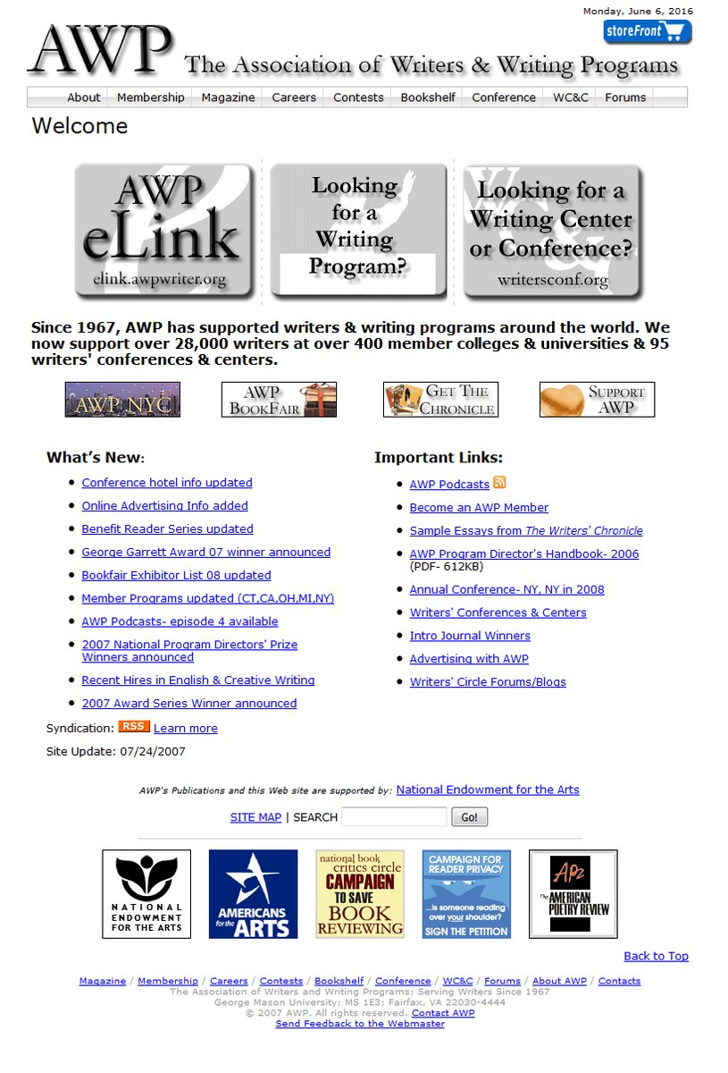
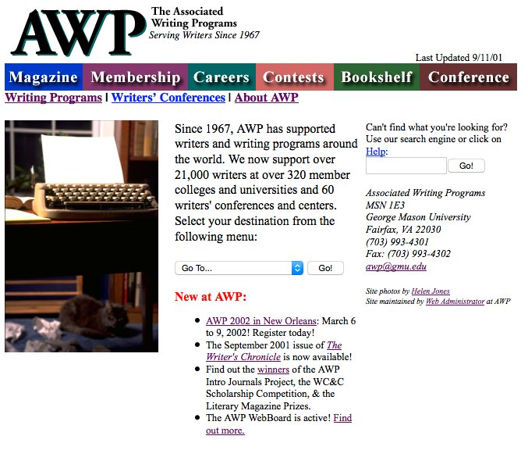

Kate McDevitt ‏@kate_bookworm
Let’s start off with a look at the main page of the #AWPwebsite.
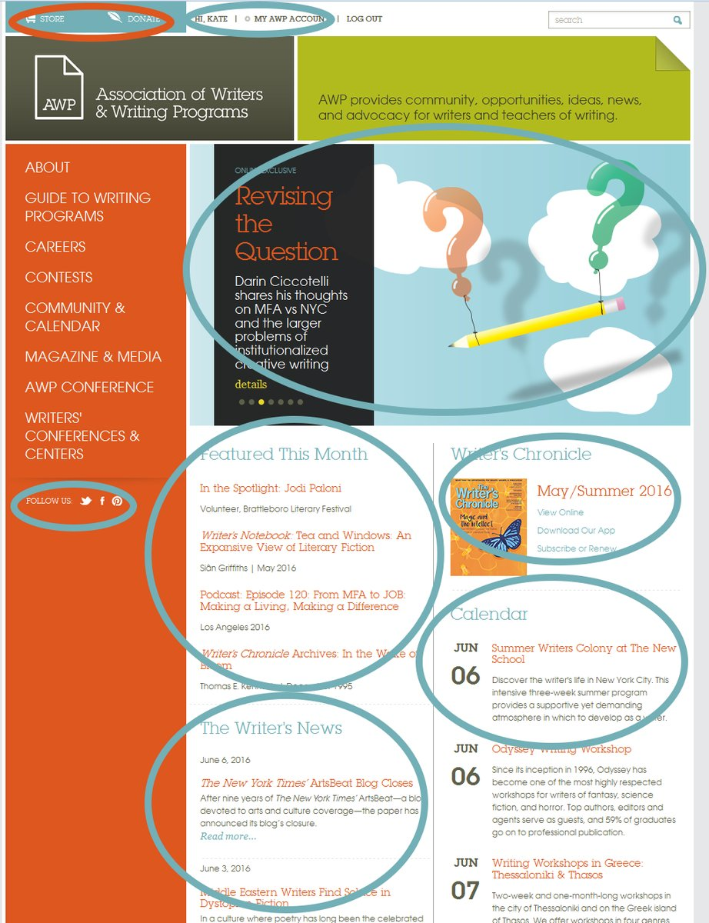

Kate McDevitt ‏@kate_bookworm
The #AWPwebsite main page slide show tells you what’s new on the site, from award winners to content.
Kate McDevitt ‏@kate_bookworm
You can easily get to the most recent news, the most recent issue of the Writer’s Chronicle, or the store from the main page. #AWPwebsite
Kate McDevitt ‏@kate_bookworm
My fave part of the main #AWPwebsite is Featured This Month. I change this at the start of every month to showcase new content.
Kate McDevitt ‏@kate_bookworm
The Calendar section has the same info as the Writer’s Calendar: WC&C and AWP dates. Members also see grant/award opportunities. #AWPwebsite
Kate McDevitt ‏@kate_bookworm
It is free to have an account on the #AWPwebsite, but there are differences between an AWP account and an AWP membership.

Kate McDevitt ‏@kate_bookworm
Here’s a handy infographic of pages that #AWPwebsite account holders, WC subscribers, and AWP members can view:
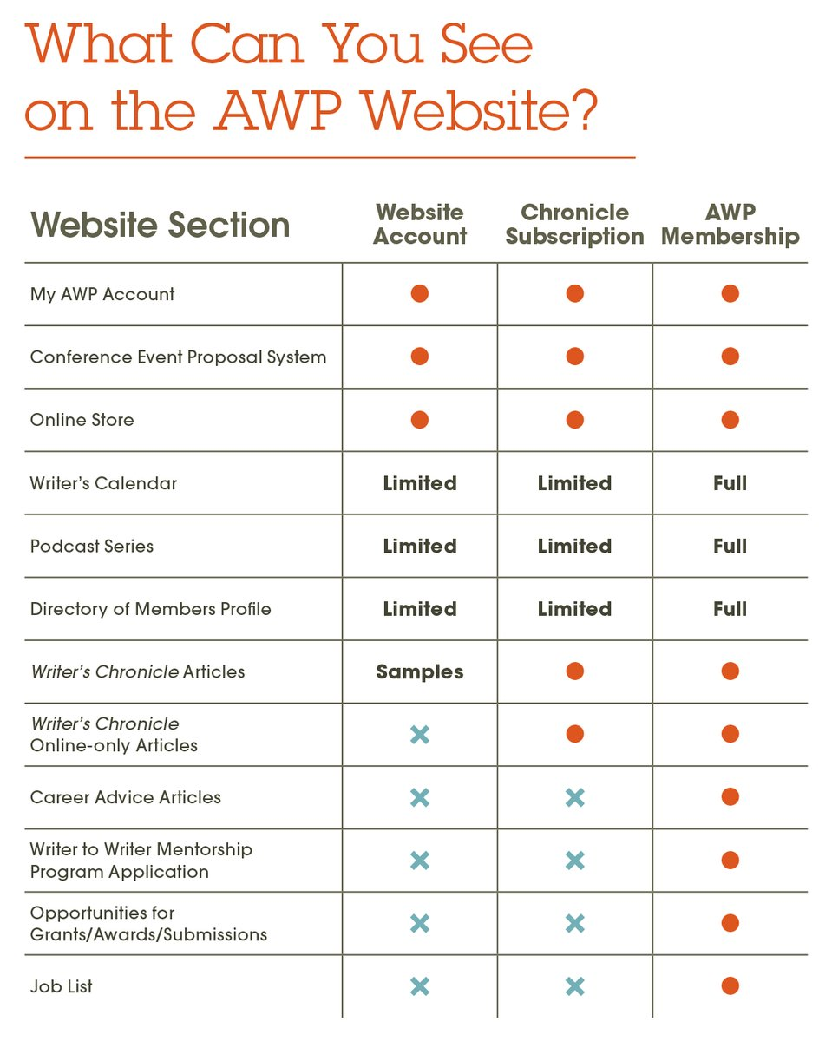
Kate McDevitt ‏@kate_bookworm
An #AWPwebsite account lets you do such things as participate in the conference and make store purchases.
Kate McDevitt ‏@kate_bookworm
A membership in AWP, on the other hand, gives you access to members-only content like Job List, grant/award opportunities, etc. #AWPwebsite
Kate McDevitt ‏@kate_bookworm
Heads-up! In July, we'll have a free preview weekend where you'll be able to view all the members-only parts of the #AWPwebsite
Kate McDevitt ‏@kate_bookworm
The current #AWPwebsite has 8 sections: About, Guide, Careers, Contests, Community & Calendar, Magazine & Media, Conference, and WC&C.
Kate McDevitt ‏@kate_bookworm
I’d like to show you the best parts of these sections on the #AWPwebsite, including some pages you might not have seen before!
Kate McDevitt ‏@kate_bookworm
#AWPwebsite About: Check out this great Photo Gallery of @awpwriter's past. https://www.awpwriter.org/about/photo_gallery …
Kate McDevitt ‏@kate_bookworm
#AWPwebsite About: Let the world know you're an AWP member by adding one of these badges to your blog/website. https://www.awpwriter.org/about/press_room_graphicsphotos …
Kate McDevitt ‏@kate_bookworm
#AWPwebsite Guide: The searchable Guide to Writing Programs is one of our three most popular pages! https://www.awpwriter.org/guide/guide_writing_programs …
Kate McDevitt ‏@kate_bookworm
#AWPwebsite Guide: Want a more personal look at programs? Check out the Campus Visit Video Series (CCing available) https://www.awpwriter.org/guide/campus_videos …
Kate McDevitt ‏@kate_bookworm
#AWPwebsite Careers: The Job List is also popular. Only 2 AWP staffers curate hundreds of job listings for members: https://www.awpwriter.org/careers/job_list …
Kate McDevitt ‏@kate_bookworm
#AWPwebsite Careers: Need some career advice? We’ve got over a hundred articles dating back to 1999! https://www.awpwriter.org/careers/career_advice …
Kate McDevitt ‏@kate_bookworm
#AWPwebsite Contests: archive pages give us a look back at previous winners.
AS: https://www.awpwriter.org/contests/awp_award_series_previous_winners …
GG: https://www.awpwriter.org/contests/george_garrett_award_previous_winners …
Kate McDevitt ‏@kate_bookworm
#AWPwebsite Contests: archive pages give us a look back at previous winners.
SPPA: https://awpwriter.org/contests/small_press_publisher_award_previous_winners …
Intro: https://awpwriter.org/contests/intro_journals_project_overview …
Kate McDevitt ‏@kate_bookworm
#AWPwebsite Contests: archive pages give us a look back at previous winners.
WC&C: https://awpwriter.org/contests/wcc_scholarships_previous_winners …
NPDP: https://awpwriter.org/contests/national_program_directors_prize_previous_winners …
Kate McDevitt ‏@kate_bookworm
#AWPwebsite Contests: members can find writing grants, awards, calls for submissions, and more! https://www.awpwriter.org/contests/opportunities_grants_awards_publications …
Kate McDevitt ‏@kate_bookworm
Did you know it is FREE to submit a job or opportunity listing to the #AWPwebsite? https://www.awpwriter.org/careers/job_list … https://www.awpwriter.org/contests/submit_listing …
Kate McDevitt ‏@kate_bookworm
#AWPwebsite Community & Calendar: You've got to check out all of our spotlighted members: https://www.awpwriter.org/community_calendar/spotlight_overview …
Kate McDevitt ‏@kate_bookworm
#AWPwebsite Community & Calendar: Read some thoughts from our Writer to Writer mentors & mentees: https://www.awpwriter.org/community_calendar/mentorship_program_reflections …
Kate McDevitt ‏@kate_bookworm
#AWPwebsite Community & Calendar: If you missed any of our previous tweet chats, they're all archived here: https://www.awpwriter.org/community_calendar/tweet_chats …
Kate McDevitt ‏@kate_bookworm
#AWPwebsite Community & Calendar: Members can use the Directory of Members to promote themselves as writers: https://www.awpwriter.org/community_calendar/directory_members …
Kate McDevitt ‏@kate_bookworm
#AWPwebsite Magazine & Media: the free sample articles about #writing on this page change almost every day! https://www.awpwriter.org/magazine_media/writers_chronicle_overview …

Kate McDevitt ‏@kate_bookworm
#AWPwebsite Magazine & Media: We've got more than 1,300 articles about #writing available to members & subscribers: https://www.awpwriter.org/magazine_media/writers_chronicle_features …
Kate McDevitt ‏@kate_bookworm
#AWPwebsite Magazine & Media: Read through the WC archive already? Then you can read The Writer's Notebook blog: https://www.awpwriter.org/magazine_media/writers_notebook …
Kate McDevitt ‏@kate_bookworm
#AWPwebsite Magazine & Media: Looking for more summer reading? Try some books by AWP members: https://www.awpwriter.org/magazine_media/writers_chronicle_bookshelf …
Kate McDevitt ‏@kate_bookworm
#AWPwebsite Magazine & Media: Or change it up and listen to writers in our podcast series—over 120 episodes! https://www.awpwriter.org/magazine_media/podcast_series …
Kate McDevitt ‏@kate_bookworm
#AWPwebsite Magazine & Media: Want something more visual? Videos are now available from the past 4 conferences! https://www.awpwriter.org/magazine_media/videos …

Kate McDevitt ‏@kate_bookworm
#AWPwebsite AWP Conference: Speaking of images, we've got past conference photo galleries as well. Here's #AWP15's: https://www.awpwriter.org/awp_conference/archive/2015/photo_gallery …
Kate McDevitt ‏@kate_bookworm
#AWPwebsite AWP Conference: Don't miss our featured presenters! @azarnafisi will be delivering the keynote at #AWP17 https://www.awpwriter.org/awp_conference/presenters_featured_presenters_overview …
Kate McDevitt ‏@kate_bookworm
#AWPwebsite AWP Conference: And #AWP17 bookfair exhibit sales will be open at the end of this month! https://www.awpwriter.org/awp_conference/bookfair_overview …
Kate McDevitt ‏@kate_bookworm
#AWPwebsite Writers' Conferences & Centers: Find your perfect conference, center, festival, retreat, or residency: https://www.awpwriter.org/wcc/directory_conferences_centers …
Kate McDevitt ‏@kate_bookworm
How about some #AWPwebsite tips? Manage your account here: https://www.awpwriter.org/user/login_settings … Update your address, add a bio, see receipts, etc.
Kate McDevitt ‏@kate_bookworm
#AWPwebsite To edit any of your account info, be sure to first click the green EDIT buttons for each section.
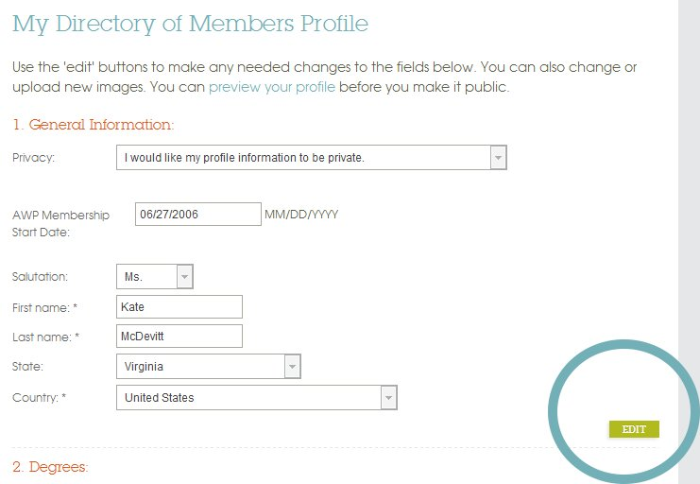
Kate McDevitt ‏@kate_bookworm
If you spot a teal box on the #AWPwebsite, it's usually a button with a useful quick link you can follow.
Kate McDevitt ‏@kate_bookworm
#AWPwebsite Many of our pages have relevant contact information in the rightmost column.
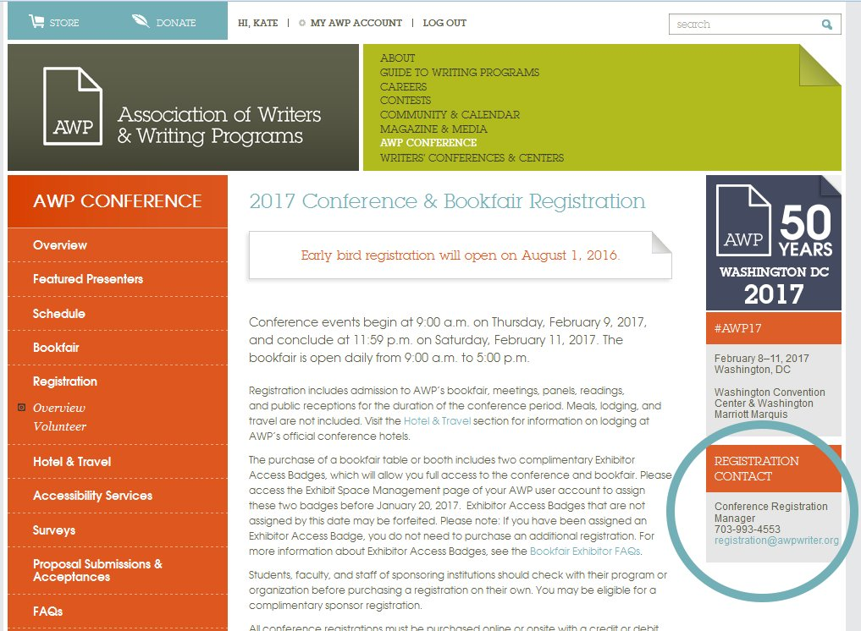

Kate McDevitt ‏@kate_bookworm
#AWPwebsite Some pages also have downloadable information in the right hand column.
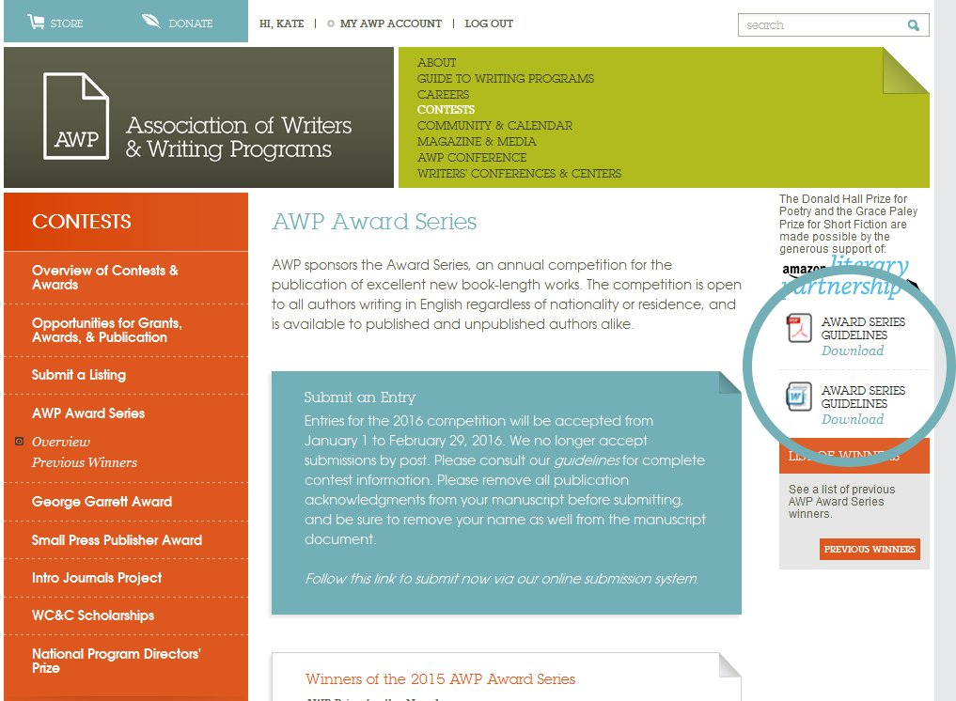

Kate McDevitt ‏@kate_bookworm
Want to share a #AWPwebsite page via social media or email? There’s a tool for that in the footer of every page!
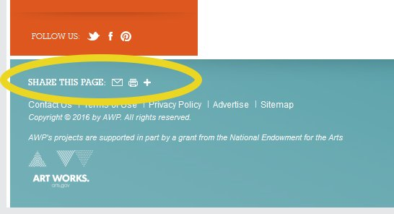
Kate McDevitt ‏@kate_bookworm
The redesigned #AWPwebsite launched in 2012. We’ve got a few more pieces we’re finishing up still.
Kate McDevitt ‏@kate_bookworm
When that’s done, our development plan is to rebuild the #AWPwebsite to be more accessible via mobile and assistive devices.

Kate McDevitt ‏@kate_bookworm
We also have plans to make parts of the #AWPwebsite more interactive and customizable.
Kate McDevitt ‏@kate_bookworm
Have a suggestion about what YOU would like to see on the #AWPwebsite? Please email suggestions@awpwriter.org.
Kate McDevitt ‏@kate_bookworm
The redesigned #AWPwebsite will celebrate its 4th birthday on Aug 22. Check out the #WritersNews then for a state of the website report.
Kate McDevitt ‏@kate_bookworm
And keep an eye on social media for a free preview of exclusive content on the #AWPwebsite from July 8–10!
Kate McDevitt ‏@kate_bookworm
If you've got any more questions about the #AWPwebsite, feel free to email me any time at webmaster@awpwriter.org.

AWP ‏@awpwriter
Thanks so much for joining us for today's tweet chat about the #AWPwebsite. Our July chat will be about our #W2W mentorship program.

