AWP’s Twenty-fourth Tweet Chat: #AWPWCC
March 16, 2017 from 3:00-4:00 p.m. ET

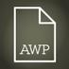AWP‏ @awpwriter
#AWPWCC includes more than just conferences! Learn about the many options out there for writers at our tweet chat today at 3pm ET. 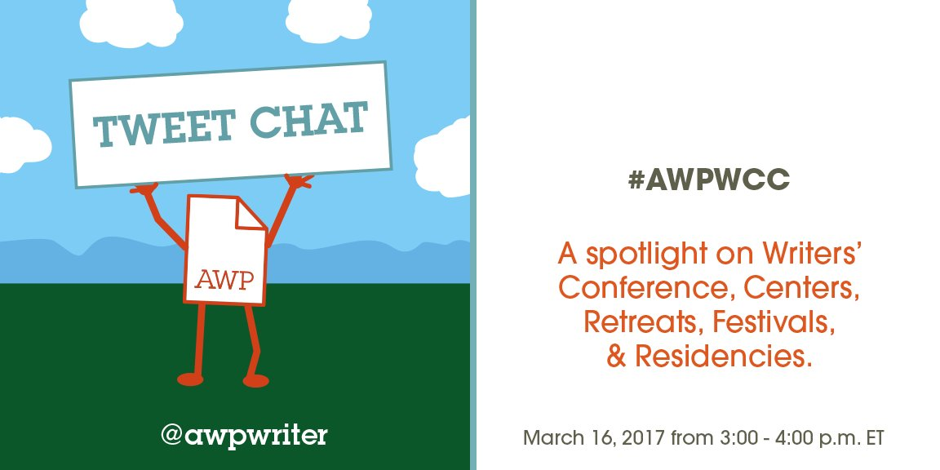
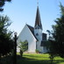Poetry at Round Top‏ @poetryroundtop
Warming up for #AWPWCC chat. *stretches fingers, wrists, hamstrings*
AWP‏ @awpwriter
Thank you for joining us today for our #AWPWCC chat!

AWP‏ @awpwriter
With us for the next hour is our Membership Coordinator, Kenny Lakes, @usyboroda. #AWPWCC
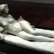George's Dryad‏ @GeorgesDryad
@awpwriter @usyboroda Hi Kenny! Thanx 4 hosting this. Plz tell us about how #AWPWCC ensures access for disabled members across the vast nation?
UsyBoroda‏ @usyboroda
WC&C programs are independent of WC&C. We do not have control over their practices and policies, however (cont.) #AWPWCC
UsyBoroda‏ @usyboroda
@GeorgesDryad @awpwriter We try to create spaces where directors of these programs can come together to discuss best practices and solutions to issues #AWPWCC
UsyBoroda‏ @usyboroda
We try to create spaces where directors of these programs can come together to discuss best practices and solutions to issues #AWPWCC
George's Dryad‏ @GeorgesDryad
Awesome! Where do you send directors when they ask 4 help on #disability #access etc. Hopefully not to #AWP17! Yikes!
UsyBoroda‏ @usyboroda
The directors tend to be very willing to share with one another, and help each other grow. #AWPWCC
UsyBoroda‏ @usyboroda
@GeorgesDryad @awpwriter We welcome suggestions on ways conferences, centers, retreats, residencies, & festivals can improve. We will share these suggestions #AWPWCC
George's Dryad‏ @GeorgesDryad
Yeah, they have gone silent towards the #ADAviolations at #AWP17. No apology no concern no nothing. So maybe you can help rep 4 us?
AWP‏ @awpwriter
Also discussing & answering questions is our Director of Membership @DianeZinna. #AWPWCC
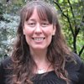
AWP‏ @awpwriter
Ask a question about WC&C programs or the WC&C scholarship using #AWPWCC.
UsyBoroda‏ @usyboroda
Hello! I am Kenny Lakes, the Membership Coordinator at @awpwriter, and I work closely with our WC&C members #AWPWCC
UsyBoroda‏ @usyboroda
We will be using the hashtag #AWPWCC throughout this conversation. Make sure to use it if you join in!
UsyBoroda‏ @usyboroda
Directors of our WC&C member programs have been invited to share their own stories with you today #AWPWCC
UsyBoroda‏ @usyboroda
WC&C stands for Writers’ Conferences & Centers, but it also supports retreats, residences, festivals, and more #AWPWCC

UsyBoroda‏ @usyboroda
You can find all of these amazing programs in AWP’s Directory of Conferences & Centers https://www.awpwriter.org/wcc/directory_conferences_centers … #AWPWCC
Peter E. Murphy‏ @MurphyWriting
Hello, all! What a nice afternoon for a Live Tweet Q&A. #AWPWCC #murphywriting #stocktonuniversity
UsyBoroda‏ @usyboroda
@MurphyWriting Thank you for joining us! #AWPWCC

Poetry at Round Top‏ @poetryroundtop
Excited to be part of the tweet chat (thanks @awpwriter!) and learn more about other WC&C programs. #AWPWCC
GrubStreet‏ @GrubWriters
Great opportunity for writers to ask their conference and retreat questions. Starting now! #awpwcc

UsyBoroda‏ @usyboroda
The directory can be sorted by location—by state, region of the U.S., or by country. #AWPWCC 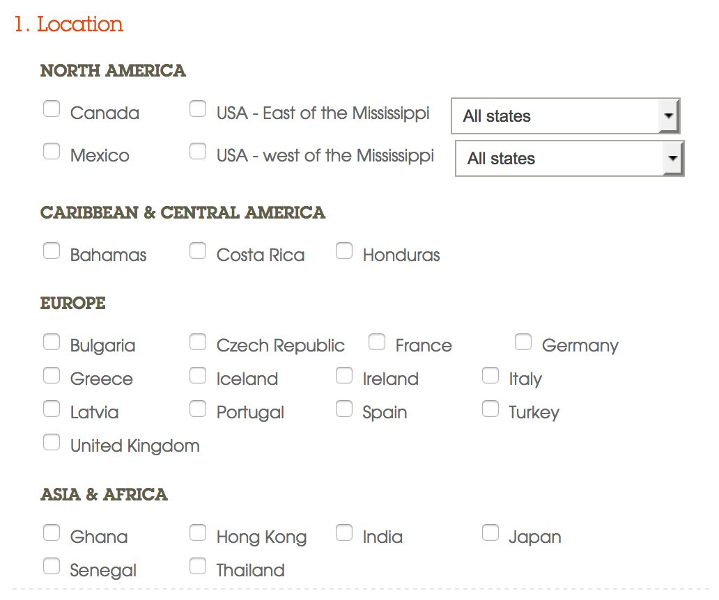

UsyBoroda‏ @usyboroda
You can also sort the directory by program type (conference, center, retreat, residency, & festival) #AWPWCC
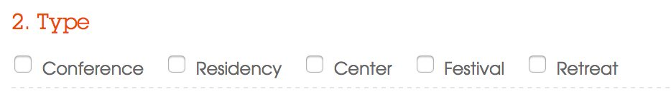

UsyBoroda‏ @usyboroda
You can limit your search by genres offered as well #AWPWCC
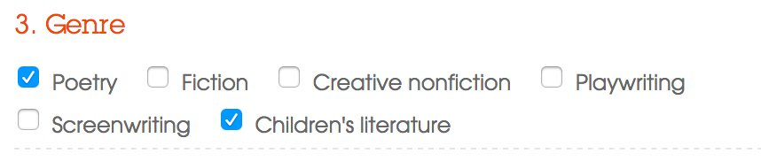
George's Dryad‏ @GeorgesDryad
@usyboroda Not exactly? Was really wanting to search for "disabled and D/deaf" panels but we're erased by these categories. Cld we change? #AWPWCC
UsyBoroda‏ @usyboroda
@GeorgesDryad This is definitely a field we can add more categories to. We can add an identifier for programs that address disabled and D/eaf #AWPWCC

Great Reads Boston‏ @GreatReadsBOS
Great opportunity for writers to ask their conference and retreat questions. Starting now! #awpwcc via GrubStreet
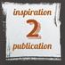Antioch I2P Program‏ @Inspiration2Pub
Any suggestions for programs promoting diversity or social justice? #awpwcc
UsyBoroda‏ @usyboroda
@Inspiration2Pub This often comes up at our yearly group meeting. Do other programs have advice on diversity and social justice? #AWPWCC
Poetry at Round Top‏ @poetryroundtop
Great question. We feature poets who reflect diverse views/backgrounds & offer scholarships, but more work always needed. #AWPWCC
Poetry at Round Top‏ @poetryroundtop
We also work with schools to bring kids out for poetry workshops & readings #AWPWCC
George's Dryad‏ @GeorgesDryad
@Inspiration2Pub Thanx Antioch: Actually, ya'll already cool & we know yr on #disabilitypride #disabilityrights & the basics. Could u advise #AWP abt it?
GrubStreet‏ @GrubWriters
@Inspiration2Pub #awpwcc The Muse offers scholarships to writer's of color, writers living w/ disability, & conference newbies! (1/2)
UsyBoroda‏ @usyboroda
This is great! Are there others who have scholarships like this? #AWPWCC
Peter E. Murphy‏ @MurphyWriting
@usyboroda #awpwcc Murphy Writing of Stockton University offers scholarships specifically for those who are new to our programs.
GrubStreet‏ @GrubWriters
@GeorgesDryad @Inspiration2Pub Always looking to expand and learn! That's a fantastic idea! Every yr we look to incorporate all #awpwcc
GrubStreet‏ @GrubWriters
@Inspiration2Pub #awpwcc we also have panels/discussions specifically focused on diversity in the lit world http://museandthemarketplace.com/overview-details-2/ …
George's Dryad‏ @GeorgesDryad
@GrubWriters @Inspiration2Pub Hi Grub Street! We're really curious abt yr panels & discussions on disability anything. #TellUsMore #AWPWCC
GrubStreet‏ @GrubWriters
Hey! @GeorgesDryad @Inspiration2Pub We have multiple sessions that focus on writers of color. These include agents/editors & writers #awpwcc
George's Dryad‏ @GeorgesDryad
@GrubWriters @Inspiration2Pub Awesome! Maybe a panel on disability anything could be in yr future b/c POC r sometimes also disabled? Sending <3
GrubStreet‏ @GrubWriters
@GeorgesDryad @Inspiration2Pub #awpwcc Here's a link to those sessions where you can read their descriptions! https://themusethemarketplace2017.sched.com/audience/Writers+of+Color+Track?iframe=no

UsyBoroda‏ @usyboroda
Member listings have full contact information, faculty listings, deadlines, scholarship information, and photos #AWPWCC
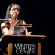TheWritersCenter‏ @writerscenter
Hey there--would love to find a way to make our WC&C sessions and membership with AWP more productive and well attended #AWPWCC
UsyBoroda‏ @usyboroda
WC&C-related events are a searchable option in our AWP Conf. schedule each year. be sure to check them out! #AWPWCC https://www.awpwriter.org/awp_conference/schedule_overview …
Diane Zinna‏ @DianeZinna
@writerscenter #AWPWCC There is now a public WC&C reception at the annual conference and it was really well attended these past 3 years!

UsyBoroda‏ @usyboroda
Are you looking for more engagement in the writing community? Need some guidance on where to go next? #AWPWCC
UsyBoroda‏ @usyboroda
Just need some time away to write and a space to do it in? These programs are here to fill those needs. #AWPWCC
Meg Day‏ @themegdaystory
@usyboroda @awpwriter If programs r not accessible, theyre not here 2 fill our needs. Why support residencies that r not accessible? #AWPWCC
UsyBoroda‏ @usyboroda
@themegdaystory @awpwriter Thank you for this question. I think this is an important one and not one that can be easily answered in 140 characters. (cont.) #AWPWCC
Meg Day‏ @themegdaystory
@usyboroda @awpwriter #AWPWCC Yall have power! Show res/retreats that #nature & #time & #space to write ≠ #ableism
George's Dryad‏ @GeorgesDryad
@usyboroda @themegdaystory @awpwriter yeah but this is same reply we got from @ChristianTeresi it wuz yr idea to hold #tweetchat no? #AWPWCC #AWP17
UsyBoroda‏ @usyboroda
@themegdaystory @awpwriter I see the WC&C program as serving as a place where these programs can improve, and can strive to serve the needs of all. #AWPWCC
George's Dryad‏ @GeorgesDryad
"strive" key word there. Lot of us still hurt abt ways we were kept out kept off stage of #AWP17 acknowledge + apologize wld go loong way
Meg Day‏ @themegdaystory
@GeorgesDryad @usyboroda @awpwriter I think we have a really different understanding of the word "needs" #AWPWCC We're not talking needs.
UsyBoroda‏ @usyboroda
@themegdaystory @awpwriter With the resources we can provide, and the passion of people who care (like you!), we can help create a more supportive community #AWPWCC
Meg Day‏ @themegdaystory
@usyboroda @awpwriter Sorry, I'm busy w #paperwork gettin my passion to get yall in line. I cain't do AWPs job & mine. #AWPWCC

Peter E. Murphy‏ @MurphyWriting
The Winter Getaway takes place over MLK weekend. Its closing is always dedicated to racial & social unity. http://wintergetaway.com/ #AWPWCC
UsyBoroda‏ @usyboroda
I would like to take some time to acknowledge some of our newest WC&C members #AWPWCC
UsyBoroda‏ @usyboroda
Enhancing the Tulsa art community, @tulsaartists supports local literary artists & attracts national writers http://www.tulsaartistfellowship.org/ #AWPWCC
Poetry at Round Top‏ @poetryroundtop
Curious to hear from other WC&C programs (esp. annual events) - do you have other engagement/activities year-round? #awpwcc

Peter E. Murphy‏ @MurphyWriting
@poetryroundtop Yes. Murphy Writing offers both week-long and day-long programs year-round. #awpwcc
George's Dryad‏ @GeorgesDryad
@poetryroundtop Hi there! One thing we've been working on is #ASL & #captions & hand-outs & accessible doors & ramps & what have ya'll been up to?
Poetry at Round Top‏ @poetryroundtop
@GeorgesDryad Still thinking abt year-round engagement! We're lucky to have accessible facilities @RTFInstitute. #ASL & translation gr8 idea
George's Dryad‏ @GeorgesDryad
@poetryroundtop @RTFInstitute Luv this, truly, but also into ways yr conference cld include disabled poets, writers, artists as experts on panels on boards on top
Poetry at Round Top‏ @poetryroundtop
@GeorgesDryad @RTFInstitute Yes and yes. We have 6-9 feat. poets/yr & this shd be considered - all views/abilities impt. #AWPWCC

UsyBoroda‏ @usyboroda
The mission of @IWWG is to foster the personal and professional empowerment of women through writing https://iwwg.wildapricot.org/ #AWPWCC
UsyBoroda‏ @usyboroda
(1/2) A literary center in NY’s Hudson Valley, @PoemBarn is stocked with a comprehensive independent poetry collection #AWPWCC
UsyBoroda‏ @usyboroda
(2/2) @PoemBarn also offers onsite and online workshops, craft talks, readings, and book arts for all ages #AWPWCC
George's Dryad‏ @GeorgesDryad
#AWPWCC Plz send info on how #AWPWCC can advocate 4 disabled writers during day when #EndOfDisability trending. Advocate 4 us?
UA Poetry Center‏ @UAPoetryCenter
@UAPoetryCenter features a 70,000+ poetry library, K-12 education programs, reading & lecture series, residencies, & more #AWPWCC

Meg Day‏ @themegdaystory
@awpwriter Most of your res/retreats listed r not accessible. What r yall doing to incentivize residencies to be more accessible? #AWPWCC
UsyBoroda‏ @usyboroda
Accessibility questions come up at our annual director's meeting at AWP's conference. They have discussions on how to improve. #AWPWCC
Meg Day‏ @themegdaystory
I'm glad! Do you have disabled people at your annual director's meeting? #AWPWCC
UsyBoroda‏ @usyboroda
Directors and non-directors who openly identified as such do attend, and incorporated their experiences into the discussions. #AWPWCC
UsyBoroda‏ @usyboroda
It is an open forum, and all are welcome #AWPWCC

Meg Day‏ @themegdaystory
#AWPWCC Thanks! I bet @AWPDisability Caucus would appreciate an invite next year at #AWP18
George's Dryad‏ @GeorgesDryad
Great. Who is the ADA Coordinator at #AWP? Yeah, ya'll need one bad
Meg Day‏ @themegdaystory
YESYES to this. #AWPWCC
Meg Day‏ @themegdaystory
Convo might-> real strux change if included #DisLit or @AWPDisability AWP withheld support from ableist orgs #AWPWCC
UsyBoroda‏ @usyboroda
I would love to talk with @AWPDisability and others on how to better disseminate information and advice to program directors. #AWPWCC

Meg Day‏ @themegdaystory
@usyboroda @awpwriter Yes @AWPDisability is a resource but yall need disabled folks in your meetings. Like, maybe as directors. #AWPWCC
UsyBoroda‏ @usyboroda
We have a monthly newsletter for directors, where some have shared how to improve on accessibility and equity #AWPWCC
UsyBoroda‏ @usyboroda
At AWP, we try to create spaces where WC&C members can share advice on how to improve with one another. #AWPWCC
George's Dryad‏ @GeorgesDryad
But kind of like how? Since even main conf #AWP17 demonstrates failure of access on basic level? Is #AWP17 role model? HOPE NOT

UsyBoroda‏ @usyboroda
@WCUPoetry offers workshops in traditional poetic craft and provides a national forum to discuss major trends in contemporary poetry #AWPWCC
UsyBoroda‏ @usyboroda
Flatiron Writers Room serves the broader western NC by offering workshops, salons, a contest & other events. http://www.flatironwriters.com/ #AWPWCC
UsyBoroda‏ @usyboroda
(1/2) Mayborn Literary Nonfiction Conference is a forum for journalists, writers, readers, students, educators & the general public #AWPWCC
UsyBoroda‏ @usyboroda
(2/2) to listen to, be inspired by and practice their craft at the highest possible level. http://www.themayborn.com/conference-and-competitions … #AWPWCC
George's Dryad‏ @GeorgesDryad
Plz know that Canada's @TheFOLD_ is rocking the hell out of #access, #accommodations & #disabilitypride so maybe #TakeNotes #AWPWCC
UsyBoroda‏ @usyboroda
@writearoundpdx holds free CW workshops in hospitals, shelters, senior centers, prisons, schools & treatment facilities. #AWPWCC

UsyBoroda‏ @usyboroda
Do you write for children and young adults? Are you looking for renewal? LoonSong is for you. http://loonsong.org/index.html #AWPWCC
UsyBoroda‏ @usyboroda
WC&C membership provides your program with listings in our online directory & in our magazine https://www.awpwriter.org/wcc/directory_conferences_centers … #AWPWCC
UsyBoroda‏ @usyboroda
Membership also provides your director with all of the benefits of an individual membership with AWP https://www.awpwriter.org/about/individual_membership … #AWPWCC
UsyBoroda‏ @usyboroda
WC&C members receive discounts on our advertising rates and have the ability to promote themselves on our social media #AWPWCC
UsyBoroda‏ @usyboroda
WC&C membership helps promote your program, but it’s also about connecting to other directors and helping each other grow. #AWPWCC

UsyBoroda‏ @usyboroda
For ex., our newsletter presents innovative ideas groups are trying to get attendees & also the ideas that didn’t work out so well. #AWPWCC
TheWritersCenter‏ @writerscenter
RE diversity #AWPWCC - our creative writing program for English lang. learners w/@CR_School Inspiring to help them express their experiences
UsyBoroda‏ @usyboroda
Witnessing directors of different programs coming together over common issues & sharing experiences with one another is rewarding #AWPWCC
UsyBoroda‏ @usyboroda
If anyone is interested in joining as a WC&C member, please reach out to me at kenny@awpwriter.org #AWPWCC
UsyBoroda‏ @usyboroda
I can also be reached at 703-993-4301 to talk about membership over the phone #AWPWCC
UsyBoroda‏ @usyboroda
How will the proposed elimination @NEAarts affect your program? #AWPWCC
UsyBoroda‏ @usyboroda
What can nonprofit centers do/what should they do in a political situation when nonprofits are supposed to remain non-partisan #AWPWCC
George's Dryad‏ @GeorgesDryad
this political sitch is life/death 4 #criplit writers. trending now: #endofdisability at same time as #endofobamacare soooooo
UsyBoroda‏ @usyboroda
Want to meet brilliant poets & other word-lovers in a magical setting? Explore @poetryroundtop April 21–23 http://poetryatroundtop.org/ #AWPWCC
UsyBoroda‏ @usyboroda
The Muse (May 5-7) @grubwriters was recently voted "#1 writing conference in North America" by @TheWriterMag http://writermag.com/2017/01/17/top-10-writing-conferences-north-america/ … #AWPWCC
UsyBoroda‏ @usyboroda
Murphy Writing of Stockton University will host Get Away to Write – Spain, July 11-18, 2017. Learn more: http://murphywriting.com/writing-getaways/get-away-to-write-spain-writing-retreat.html … #AWPWCC
UsyBoroda‏ @usyboroda
Poetry & Poetry Manuscript workshops @ Vermont Postgrad Conference. Sm groups, great fac, inspiring Aug week http://www.vcfa.edu/pwc #AWPWCC
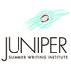Juniper Institute‏ @junipersummer
Juniper offers a weeklong immersion in the writer's life and a time for wild invention - we're pleased to be part of the #AWPWCC community!
Juniper Institute‏ @junipersummer
Getting ready for the Juniper Summer Writing Institute? Apply for a #AWPWCC scholarship toward your participation! https://www.awpwriter.org/contests/wcc_scholarships_overview …
UsyBoroda‏ @usyboroda
Thank you for joining me today! Feel free to keep having conversations through #AWPWCC on here or contact me at kenny@awpwriter.org
Meg Day‏ @themegdaystory
@usyboroda Thanks for the convo, Kenny. Tell @awpwriter a nice long twitter talkback about accessibility would be welcome/overdue #AWPWCC

GrubStreet‏ @GrubWriters
If any1 has Muse questions about scholarships, sessions, etc. feel free to email me at kaitlyn@grubstreet.org #awpwcc #Muse17
GrubStreet‏ @GrubWriters
#Muse17 Mani Iyer Scholarship: Scholarship for Writers Living with a Disability. Deadline to apply, 3/26 https://form.jotformpro.com/GrubStreet/mani-iyer-scholarship-muse-2017 … #awpwcc
AWP‏ @awpwriter
Thank you for joining us for #AWPWCC! Join us on April 4 for our next chat, about submitting #AWP18 event proposals: #SubmitAWP18

