AWP’s Twelvth Tweet Chat: #AWPWCC
February 13, 2016 from 2:00-3:00 p.m. ET

AWP ‏@awpwriter
Learn about this year's WC&C Scholarship; you could attend a writing conference for free! Chat at 2 p.m. ET #AWPWCC
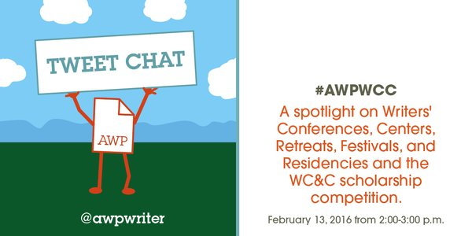

AWP ‏@awpwriter
Welcome to the WC&C tweet chat! For the next hour, we'll discuss writers' conferences, centers, retreats, festivals, & residencies. #AWPWCC
Writeaways ‏@Writeawaysinfo
Look for Writeaways at #AWPWCC

AWP ‏@awpwriter
We'll also chat about the WC&C Scholarship Competition, open now until March 30: https://www.awpwriter.org/contests/wcc_scholarships_overview … #AWPWCC
AWP ‏@awpwriter
With us today is @DianeZinna, Director of Membership. #AWPWCC
AWP ‏@awpwriter
Also with us is @usyboroda, Kenny Lakes, Membership Associate. #AWPWCC
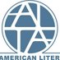ALTA ‏@LitTranslate
We are SUPER stoked to be taking part in #AWP16! Can't wait to see all the other #translation and #writing buddies there. #AWPWCC
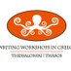WWIG: Thasos ‏@WWIGThasos
Workshops in four genres ON A GREEK ISLAND. Now reading applications to work with Forche, Cairns, Bakken, Bakopoulos, Brown, Jacobs. #AWPWCC
AWP ‏@awpwriter
To ask a question or join the discussion, just tweet using #AWPWCC
Diane Zinna ‏@DianeZinna
Hello! I’m Diane Zinna, the membership director at @AWPwriter, coordinating memberships for individuals, programs, and WC&C. #AWPWCC
Diane Zinna ‏@DianeZinna
WC&C program directors, we welcome you to tweet along this hour using the hashtag #AWPWCC.
Diane Zinna ‏@DianeZinna
WC&C stands for Writers’ Conferences & Centers, but we also help get the word out about festivals, retreats, and residencies. #AWPWCC
Kate McDevitt ‏@kate_bookworm
@DianeZinna WC&C&F&R&R would be too long for a name... #AWPWCC
Diane Zinna ‏@DianeZinna
I'm going to be shining the light on as many programs as I can today. You can view them all here: http://bit.ly/1M50A6G #AWPWCC
Diane Zinna ‏@DianeZinna
That way you can figure out where you want to go when you win our WC&C Scholarship Prize this year [wink]. http://bit.ly/1i8PgsT #AWPWCC
Christopher Bakken ‏@bakkenpoet
Still spaces in my food and travel writing (and cooking) workshop on the island of Thasos @WWIGThasos #AWPWCC
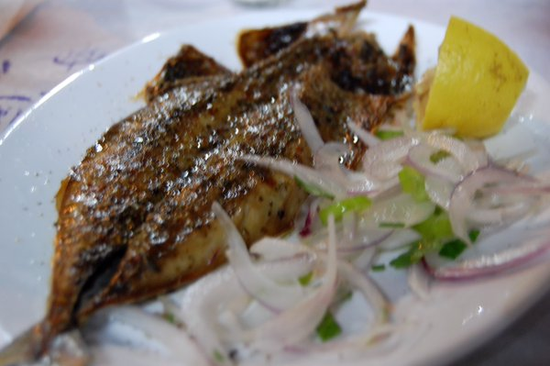
Diane Zinna ‏@DianeZinna
Each year AWP holds the WC&C scholarship contest. 3 genres. Winners use their $500 scholarships to attend one of 150+ programs. #AWPWCC
GMU English ‏@GMU_English
Here's a video about our Ireland Study Abroad Program for Creative Writing! http://bit.ly/1PCOVyc #AWPWCC #MFA #BFA
Diane Zinna ‏@DianeZinna
Our directory lists conferences for ALL levels of experience. #AWPWCC
ALTA ‏@LitTranslate
Did you know ALTA has announced the Peter Jansen Travel Fellowship? Provides funds for emerging translators! #AWPWCC http://ow.ly/YnCaC
Diane Zinna ‏@DianeZinna
WC&C: programs like Bread Loaf, @sewaneewriters, @StoryStudio Chicago, but so many others to explore. #AWPWCC
GMU English ‏@GMU_English
And here's a link on how to sign up for our Creative Writing Program in Ireland!! http://bit.ly/216QlGl #AWPWCC #MFA #BFA

Diane Zinna ‏@DianeZinna
Here's a quick link to the WC&C Scholarship Guidelines: https://www.awpwriter.org/application/public/pdf/awards/WCC_Scholarship_Guidelines.pdf … #AWPWCC
Diane Zinna ‏@DianeZinna
Our fiction judge this year is @LoriOstlund, author of AFTER THE PARADE and THE BIGNESS OF THE WORLD. #AWPWCC
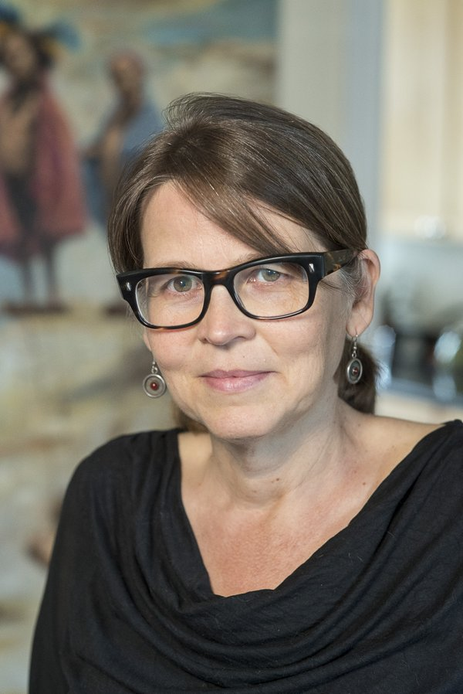
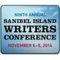Sanibel Writers Conf ‏@SanibelWriters
@awpwriter #AWPWCC @suemonkkidd keynoting at 2016 Sanibel Conference Registration open soon! http://www.fgcu.edu/siwc #shamelessplug
Diane Zinna ‏@DianeZinna
Our poetry judge is @TarfiaFaizullah. REGISTER OF ILLUMINATED VILLAGES is forthcoming from Graywolf Press #AWPWCC
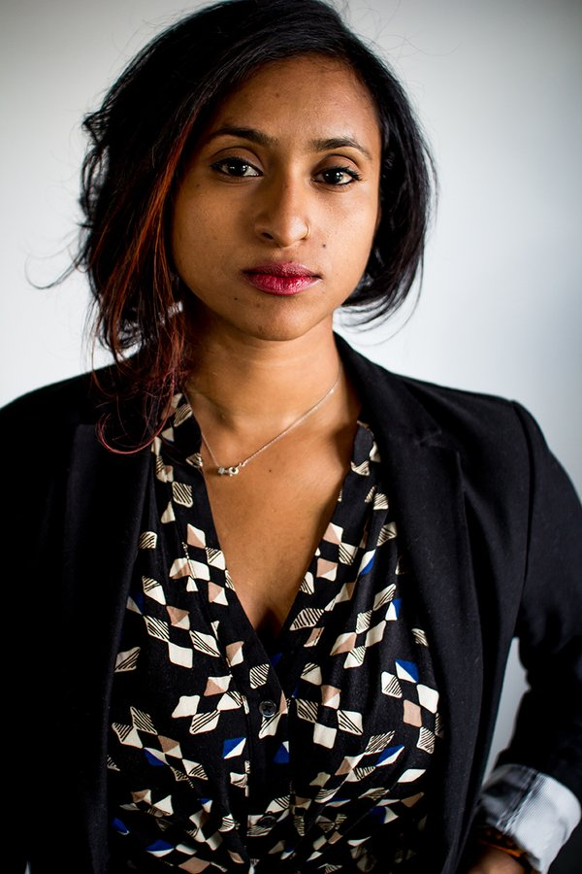

Writeaways ‏@Writeawaysinfo
Writing lack that je ne sais quoi? Writeaways France 9/25-10/2. $100 AWP discount. writeawaysinfo@gmail.com, http://www.writeaways.com #AWPWCC
Diane Zinna ‏@DianeZinna
Our creative nonfiction judge is Pushcart Prize winner is Jaquira Díaz. @jaquiradiaz #AWPWCC
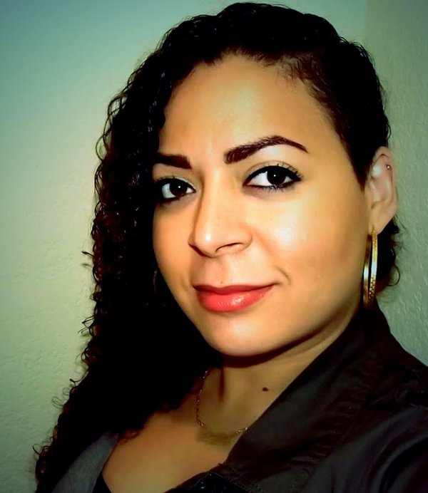
Diane Zinna ‏@DianeZinna
Want some insider information? We've received 33 entries so far in fiction; 16 in poetry; 27 in CNF #AWPWCC.

Diane Zinna ‏@DianeZinna
The WC&C Scholarship Competition closes 3/30. We hope you'll enter: https://awp.submittable.com/submit #AWPWCC
Writeaways ‏@Writeawaysinfo
Great writing takes a villa! Try Writeaways in Tuscany, 9/16-23. $100 AWP discount. http://www.writeaways.com #AWPWCC
Diane Zinna ‏@DianeZinna
Find your perfect program using the search tools in our Directory of Conferences & Centers! http://bit.ly/1M50A6G #AWPWCC
Diane Zinna ‏@DianeZinna
You can also see WC&C dates on the Writer's Calendar page of our site: http://bit.ly/1GwaslX #AWPWCC
AWP ‏@awpwriter
WC&C dates also appear in the calendar section on the main page of our website: http://awpwriter.org #AWPWCC

Diane Zinna ‏@DianeZinna
Many WC&C member programs offer discounts to AWP members. #AWPWCC
Diane Zinna ‏@DianeZinna
On our directory, you can search which conferences provide funding. Here, I did it for you! http://bit.ly/1M50A6G #AWPWCC
Diane Zinna ‏@DianeZinna
More than 15% of the students at The Muse Writers Center in Norfolk receive tuition assistance. #AWPWCC
ALTA ‏@LitTranslate
Love Italian books? Be sure to submit to the Italian Prose in Translation Award!! The deadline is April 8: http://ow.ly/YnCw2 #AWPWCC
Diane Zinna ‏@DianeZinna
The Muse Writers Center, Norfolk has a new space that’s open to the public Tuesdays. A beautiful example of community integration. #AWPWCC
The Writer's Hotel ‏@TheWritersHotel
@DianeZinna @TheWritersHotel offers $1500 in scholarships in the spirit of WC&C! #AWPWCC http://writershotel.com
Diane Zinna ‏@DianeZinna
With more than 150 members, I can’t highlight them all today--but here are some of our newest members you may wish to research. #AWPWCC
Diane Zinna ‏@DianeZinna
One of our new WC&C members, @OSSWConference, is hosting their tenth annual conference in RI June 23–25. http://bit.ly/20BTUSV #AWPWCC
Diane Zinna ‏@DianeZinna
Another new WC&C member, the Bau Institute, will hold 2 residencies in 2016 (France and Italy). http://bit.ly/24808i7 #AWPWCC
Diane Zinna ‏@DianeZinna
2 poetry workshops are a part of Beyond Baroque’s conference schedule this Aug. @BBLitArts is new to WC&C. http://bit.ly/1U5YMjq #AWPWCC
Diane Zinna ‏@DianeZinna
Join new member @pacificu for 10 days of craft talks, workshops, panels, classes and readings June 16–26. http://bit.ly/14iQzSn #AWPWCC

Diane Zinna ‏@DianeZinna
Applications for 2017 one- & two-week residencies at @wildacresNC, new WC&C member, open this summer http://bit.ly/1QGnVLX #AWPWCC
Diane Zinna ‏@DianeZinna
New WC&C member, @LitYoungstown (founded in 2015), hosts classes, readings, and other events and programs. http://bit.ly/1WpNXHD #AWPWCC
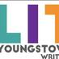Lit Youngstown ‏@LitYoungstown
Lit Youngstown Retweeted Diane Zinna
@DianeZinna Thanks for the mention! Warm greetings from snowy northeast Ohio.
Diane Zinna ‏@DianeZinna
@LitYoungstown Thanks for being a part of this! #AWPWCC

Diane Zinna ‏@DianeZinna
Attend new WC&C member, Martha’s Vineyard Institute of Creative Writing Summer Seminar, July 10–July 23. http://bit.ly/1SvAAr0 #AWPWCC

ALTA ‏@LitTranslate
We're thrilled to see all the #translation events at #AWP16. We've compiled them here! http://ow.ly/YnCIJ #AWPWCC
Diane Zinna ‏@DianeZinna
New WC&C memb., @SABookFestival, is a FREE, annual, daylong event that unites readers and writers (April 2). http://bit.ly/1TlSxHE #AWPWCC
Writeaways ‏@Writeawaysinfo
Writing lack that je ne sais quoi? Writeaways France 9/25-10/2. $100 AWP discount. writeawaysinfo@gmail.com, http://bit.ly/1Tm6Rjh #AWPWCC
Diane Zinna ‏@DianeZinna
Alderworks Alaska Writers & Artists Retreat, new WC&C, offers residencies in log cabins along a wild creek http://bit.ly/1oneOts #AWPWCC
Diane Zinna ‏@DianeZinna
Want to know more about the WC&C groups? Join us at the WC&C reception at #AWP16 on Sat, 4-2 at 6:30pm! https://www.awpwriter.org/awp_conference/event_detail/8002 … #AWPWCC

New School Writing ‏@NewSchoolWrites
Summer Writers Colony @TheNewSchool offers workshops in fiction, nonfiction, and poetry. June 6-23, 2016: http://www.newschool.edu/summerwriters #AWPWCC
Diane Zinna ‏@DianeZinna
Come have a drink, learn more about the WC&C writing programs, and connect with their directors at #AWP16. #AWPWCC
Diane Zinna ‏@DianeZinna
WC&C really exists to help connect you with these programs--and connect their directors to each other. #AWPWCC
Diane Zinna ‏@DianeZinna
We want to see all of these programs thrive and reach the writers who need them! #AWPWCC
Sharon Dolin ‏@Shazzypoet
#AWPWCC one need- and merit-based $500 scholarship for this June's Writing About Art in Barcelona http://www.sharondolin.com/barcelona-workshops/ …
Diane Zinna ‏@DianeZinna
I have a lot more to share with you. Here are the programs you need to apply to now because application deadlines are approaching! #AWPWCC
Writeaways ‏@Writeawaysinfo
Great writing takes a villa! Try Writeaways in Tuscany, 9/16-23. $100 AWP discount. writeawaysinfo@gmail.com http://ow.ly/YoELA #AWPWCC
Diane Zinna ‏@DianeZinna
Apply to Paris Café Writing by Apr 20 two attend a one-week seminar this June. http://bit.ly/1LrU6gw #AWPWCC
Diane Zinna ‏@DianeZinna
Attend @WritingestState’s Spring Conference in Greensboro, NC April 23 for a full day of instruction and camaraderie #AWPWCC
Sharon Dolin ‏@Shazzypoet
Ana Aguilar-Amat Catalan Guest Writer @Writing About Art in Barcelona #AWPWCC http://www.sharondolin.com/barcelona-workshops/ …
The Writer's Hotel ‏@TheWritersHotel
@TheWritersHotel Work with Editors on your ms today, pre-conference in NYC! On site: workshop/agents & more. http://writershotel.com #AWPWCC

Diane Zinna ‏@DianeZinna
Apply to the 2018 Margery Davis Boyden Wilderness Writing Residency by March 1, 2016 http://bit.ly/1QjSUNC #AWPWCC
Diane Zinna ‏@DianeZinna
Application deadline is April 15 for @sewaneewriters’s July conference http://bit.ly/1KnR6a4 #AWPWCC
Diane Zinna ‏@DianeZinna
@UNM Summer Writer’s Conference (Jul 24–31) is accepting apps until March 1 http://bit.ly/1PP5ZiH #AWPWCC
Diane Zinna ‏@DianeZinna
Write and Enjoy! Waves of Inspiration Writers’ Conference in Door County, WI with 20 workshops, 8 pres, & 16 fac membs and much more #AWPWCC
Sharon Dolin ‏@Shazzypoet
Stay @JiwarBCN Writing About Art in Barcelona June 1-10 #AWPWCC http://www.sharondolin.com/barcelona-workshops/ …

Diane Zinna ‏@DianeZinna
Find inspiration on the lovely shores of Green Bay w/noted authors, poets, & children’s writers July 21–25 http://bit.ly/1Tm1elc #AWPWCC
Diane Zinna ‏@DianeZinna
Not coming to AWP’s conference? @TWFestNOLA will be held March 30–April 3 in New Orleans http://bit.ly/1TnLMWP #AWPWCC #TWF16
ALTA ‏@LitTranslate
Are you an emerging translator? Apply for the brand new Peter K. Jansen Travel Fellowship! http://ow.ly/YnCUg #AWPWCC
AWP ‏@awpwriter
Have a question about our writers' conferences & centers or the WC&C scholarship competition? Ask now using #AWPWCC!
Diane Zinna ‏@DianeZinna
WC&C Directors who are following along with us today, what makes YOUR program special? #AWPWCC

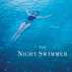Matt Bondurant ‏@mbondurant
@DianeZinna @awpwriter #AWPWCC- Welcome to The Seaside Writers Conference - this is our reading room:
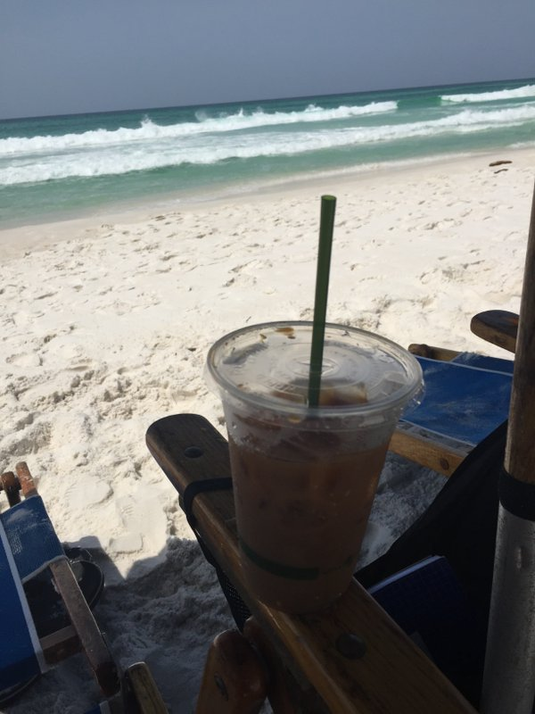
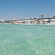Seaside Writers Conf ‏@seasidewriters
@DianeZinna @awpwriter - We are small, casual, social, and the only conference on a beach like this: #AWPWCC
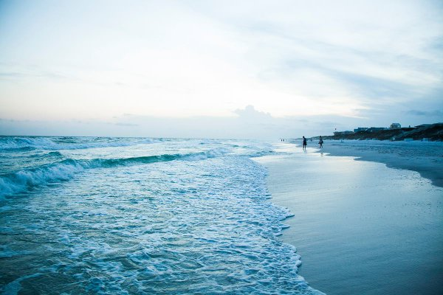
Seaside Writers Conf ‏@seasidewriters
@DianeZinna @awpwriter #AWPWCC- http://www.seasidewritersconference.com How we do happy hour in Seaside:
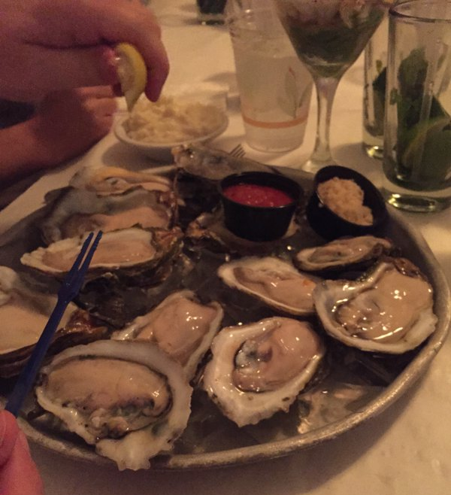
Seaside Writers Conf ‏@seasidewriters
@DianeZinna @awpwriter #AWPWCC - After readings/receptions on the beach for the amazing sunset, every night:
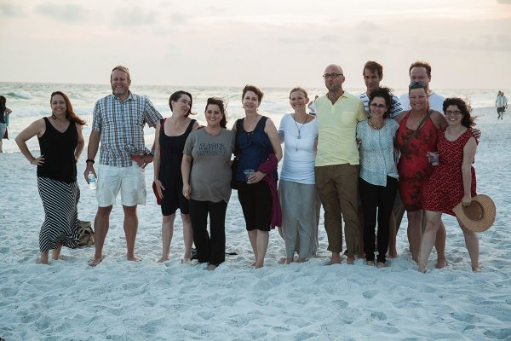
Seaside Writers Conf ‏@seasidewriters o
@DianeZinna #AWPWCC @awpwriter - Did we mention the sunsets? http://www.seasidewritersconference.com
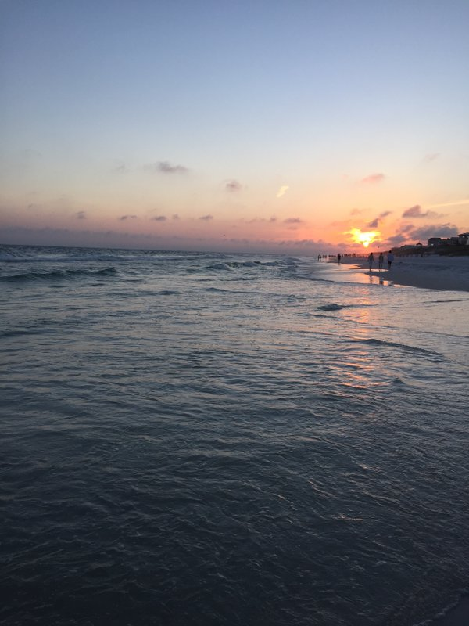
Seaside Writers Conf ‏@seasidewriters
@DianeZinna @awpwriter #AWPWCC - Check out our visiting authors/agents http://seasidewritersconference.weebly.com/2016-visiting-authors-editors-agents.html …

Seaside Writers Conf ‏@seasidewriters 24m24 minutes ago
@DianeZinna @awpwriter #AWPWCC - small, intimate workshops, in a casual environment. But we do the work at SWC...
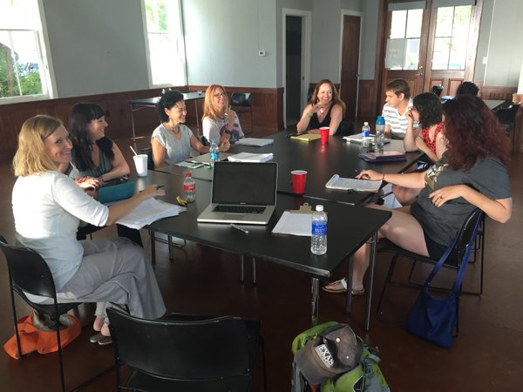
Seaside Writers Conf ‏@seasidewriters
@DianeZinna @awpwriter #AWPWCC Last years headliner @JackieMitchard and @linda_kass at an afternoon reception
Diane Zinna ‏@DianeZinna
And if you saw today's #QuestionTuesday, I'd love to hear your answer: What is your dream writers' conference? #AWPWCC
Writeaways ‏@Writeawaysinfo
Mimi Herman & John Yewell will help make your writing as compelling on the page as it is in your imagination http://www.writeaways.com #AWPWCC
Diane Zinna ‏@DianeZinna
Writing About Art in Barcelona has a $500 scholarship based on merit & need for their 2016 June Program. http://www.sharondolin.com/barcelona-workshops/ … #AWPWCC
Diane Zinna ‏@DianeZinna
@seasidewriters Is a beach retreat disguised as writers conference! Scholarships + fellowships available http://www.seasidewritersconference.com #AWPWCC
Seth Brady Tucker ‏@Airbornepoet
Fellowships worth $2000 and scholarships worth $1400! Check us out! @seasidewriters #AWPWCC

Diane Zinna ‏@DianeZinna
Anam Cara is an all-inclusive retreat in Ireland: support, creature comforts, peace to do your best work. http://bit.ly/1onho2F #AWPWCC
Diane Zinna ‏@DianeZinna
@BFWW, Berkshire Festival of Women Writers: 10 days nurturing the talents of women writers this March http://bit.ly/20BONSI #AWPWCC
ALTA ‏@LitTranslate
We think that rewarding Italian fiction in English translation is molto bene. Submit to the IPTA by April 8! http://ow.ly/YnDbg #AWPWCC
Diane Zinna ‏@DianeZinna
When I read applications for the mentorship program, so many said they found the community they needed at a writers' conference. #AWPWCC
Diane Zinna ‏@DianeZinna
There is a conference/festival/retreat/class for every kind of writer. #AWPWCC
Writeaways ‏@Writeawaysinfo
Revitalize your writing in a French chateau or Italian villa! Suitable for all levels. $100 AWP discount. http://www.writeaways.com #AWPWCC
Diane Zinna ‏@DianeZinna
Apply to @OdysseyWorkshop (Jun 6–July15) by Apr 8. For writers of fantasy, science fiction, and horror http://bit.ly/1RKn6a0 #AWPWCC
Diane Zinna ‏@DianeZinna
The @junipersummer hosts their 11th annual intensive writing program for high school students Jun 19–26. http://bit.ly/1onpRms #AWPWCC
Diane Zinna ‏@DianeZinna
(2/2) This runs concurrently with the adult program (workshops, craft sessions, Q&As, readings, ms. consultation). Apply by March 15 #AWPWCC
Diane Zinna ‏@DianeZinna
Join @_elephantrock at the Third Annual Elephant Rock Summer Solstice Retreat for Writing and Yoga Jun 13–18 http://bit.ly/217608M #AWPWCC
Diane Zinna ‏@DianeZinna
Application deadline for @_elephantrock is April 1. http://bit.ly/217608M #AWPWCC
Diane Zinna ‏@DianeZinna
Don’t miss out on @RMFWriters’s fourth annual writing retreat in Colorado Springs March 10–13 http://bit.ly/1PDc7N1 #AWPWCC
Diane Zinna ‏@DianeZinna
Are you a director of a writing conference, center, festival, retreat, residency? Large or small? Join us! http://bit.ly/1KnPi0V #AWPWCC
Diane Zinna ‏@DianeZinna
If you're a WC&C member going to #AWP16, come to the WC&C meeting on Friday, April 1 from 12-1:15pm: https://www.awpwriter.org/awp_conference/event_detail/7795 … #AWPWCC
Diane Zinna ‏@DianeZinna
If you'd like more info on being a WC&C member, come join us: Friday, April 1 from 12-1:15pm: https://www.awpwriter.org/awp_conference/event_detail/7795 … #AWPWCC
Diane Zinna ‏@DianeZinna
Remember: programs with upcoming deadlines always appear at the back of your Writer's Chronicle, too. #AWPWCC
Diane Zinna ‏@DianeZinna
Workshops in Poetry, Fiction, and Nonfiction available from @CommunofWriters http://bit.ly/1oHrAmt http://bit.ly/20C2Ck7 #AWPWCC

Writeaways ‏@Writeawaysinfo Fabulous food & wine in France & Italy. Take a Writeaways vacation with your muse! http://ow.ly/YoELA #AWPWCC
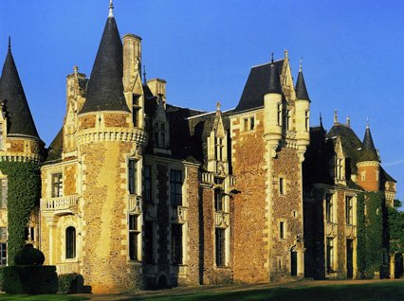
Diane Zinna ‏@DianeZinna
Be a part of @Center4BlackLit 13th annual conference is March 31–April 3 http://bit.ly/1RKtdLy #AWPWCC
Diane Zinna ‏@DianeZinna
I hope you found some inspiration today and that I'll get to meet you at #AWP16 Sat, 4-2 at 6:30pm: http://bit.ly/1XvWdXN #AWPWCC
Diane Zinna ‏@DianeZinna
The Feb. issue of the Writer's Chronicle lists ALL of our WC&C members. A great resource when you are planning out your year. #AWPWCC
Peter E. Murphy ‏@MurphyWriting
Scholarship available for international writing retreat http://p0.vresp.com/cJJfm3 #writing #amwriting
Diane Zinna ‏@DianeZinna
Another great #awpwcc program!
AWP ‏@awpwriter
Thank you for being part of #AWPWCC! Our next chat is #MFAChat on March 1. We will discuss choosing the MFA program that's right for you.
Cuppa Pulp ‏@CuppaPulpBooks
Join us as we Tweet along with @AWPwriter about the best writing conferences. Happening right now. Use #AWPWCC to be a part of it #AWPWCC
Cuppa Pulp ‏@CuppaPulpBooks
Weekly salons, workshops for revision, poetry, memoir, and free-writing all year long in the NY 'burbs. http://www.cuppapulp.com/cilk119/calendar/ … #AWPWCC
ALTA ‏@LitTranslate
Hey @awpwriter and @DianeZinna -- thanks for all the retweets and the love! We've really enjoyed the #AWPWCC -- you rock!

