AWP’s Sixteenth Tweet Chat: #AWP17BF
May 18, 2016 from 3:00-4:00 p.m. ET

AWP ‏@awpwriter
Thinking about exhibiting at #AWP17? Ask your questions today at 3:00 p.m. ET with #AWP17BF.
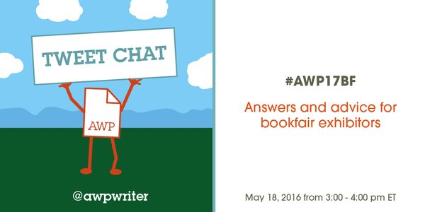

AWP ‏@awpwriter
Welcome to the #AWP17BF tweet chat. We'll discuss exhibiting at the bookfair & answer your questions.
English Wallflower ‏@engwallflower
Make sure you're following #AWP17BF beginning now!
AWP ‏@awpwriter
With us today is Cynthia Sherman, AWP's Director of Exhibits, @cshermanva. #AWP17BF
AWP ‏@awpwriter
Ask a question about the upcoming AWP bookfair at any time by tweeting with #AWP17BF.
Christian Teresi ‏@ChristianTeresi
#AWP16 LA bookfair had over 800 presses, magazines, journals, & literary orgs participate. Join them for #AWP17BF. 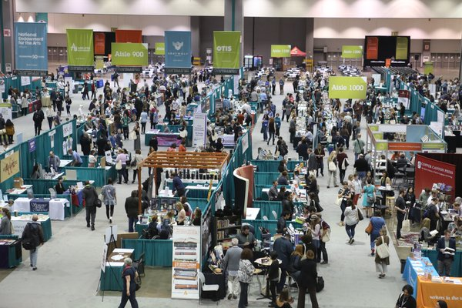
Justin L Daugherty ‏@JDaugherty1081
@ChristianTeresi @awpwriter If only the table prices hadn't gone up $75.
Christian Teresi ‏@ChristianTeresi
.@JDaugherty1081 The rates are inexpensive compared bookfairs of equal size. @cshermanva @awpwriter
Christian Teresi ‏@ChristianTeresi
.@JDaugherty1081 We had over 800 exhibitors this year. @awpwriter has to be able to pay for the entire setup up. That's a lot of union labor
Christian Teresi ‏@ChristianTeresi
.@JDaugherty1081 We keep the rates as low a possible, but we have to be able to pay for the bookfair set up & that required an increase.
Christian Teresi ‏@ChristianTeresi
.@awpwriter took on significant expenses to be able to accommodate a large more inclusive bookfair @ convention centers. @JDaugherty1081

Justin L Daugherty ‏@JDaugherty1081
@ChristianTeresi @awpwriter Understand all of this, but also know that many presses couldn't really justify the price before.
Justin L Daugherty ‏@JDaugherty1081
@ChristianTeresi @awpwriter And, many of those presses, some run by marginalized folks, are going to have to work more to justify it now.
Christian Teresi ‏@ChristianTeresi
.@JDaugherty1081 Given the expenses and staff time, the bookfair is basically a break even situation for @awpwriter.
Christian Teresi ‏@ChristianTeresi
.@JDaugherty1081 These too our our concerns, but we still have to be able to afford the cost of the bookfair. @awpwriter
Justin L Daugherty ‏@JDaugherty1081
@ChristianTeresi @awpwriter Again, I understand this. It's just...rough for many/most small presses who already have to work hard to exist.
Christian Teresi ‏@ChristianTeresi
. @JDaugherty1081 The rates have gone up 2% (booths) 4% (tables) each last five years, which is nominal considering the scope. @awpwriter
Christian Teresi ‏@ChristianTeresi
.@JDaugherty1081 The rates are going to stay the same for 2017 and 2017. @awpwriter
AWP ‏@awpwriter
@JDaugherty1081 @ChristianTeresi Thanks for voicing your concerns! Also wanted to mention we allow groups to share space to help with costs
Christian Teresi ‏@ChristianTeresi
.@JDaugherty1081 Yes, orgs. can share, which is rare for exhibits of this size. We really want as many orgs as possible to attend @awpwriter
Christian Teresi ‏@ChristianTeresi
I hear you @JDaugherty1081, but the bookfair is not possible if it cannot pay for itself.
Justin L Daugherty ‏@JDaugherty1081
@ChristianTeresi Again, understood. It's just, you know, rough out here for a press/writer/person.
Christian Teresi ‏@ChristianTeresi
We think about these concerns a lot. I hear you @JDaugherty1081. The cheapest table at BEA costs $2400.

Christian Teresi ‏@ChristianTeresi
There were more than 12,000 attendees at each of the last three conferences. We expect just as many for #AWP17BF. 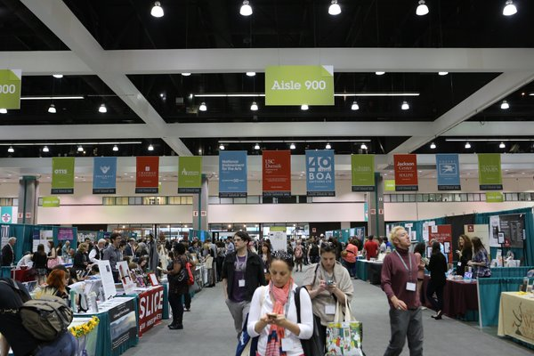
Cynthia Sherman ‏@cshermanva
#AWP17 BF sales go live in June!
Cynthia Sherman ‏@cshermanva
#awp17bf AWP uses the rolling exhibit sales process to replace the point system in to continue rewarding exhibitors for their commitment
Cynthia Sherman ‏@cshermanva
#awp17 for more details about purchasing visit https://www.awpwriter.org/awp_conference/bookfair_overview …
English Wallflower ‏@engwallflower
What can #AWP members expect to find at the #AWP17BF?
AWP ‏@awpwriter
@engwallflower Poetry, fiction, nonfic, journals, presses, writing programs, writing conferences, books, more books, and fun! #AWP17BF
AWP ‏@awpwriter
@engwallflower The #AWP17BF will have a little bit of everything. There are giveaways, author signings, swag, discounts on books, & more!
English Wallflower ‏@engwallflower
@awpwriter You had me at author signings! #AWP17BF
AWP ‏@awpwriter
@engwallflower We will have stages inside the #AWP17BF, with events throughout the conference, and also places to sit and eat/read.
Cynthia Sherman ‏@cshermanva
@engwallflower Hello! The Bookview Now stage will be live in the BF, AWP history, memorabilia, video and more fun is planned #AWP17bf

Christian Teresi ‏@ChristianTeresi
The amazing @thesablevenus & @ProfessorEA were live from the #AWP16 bookfair. #AWP17BF @awpwriter @BookViewNow https://t.co/HvpRmuYV8G
Cynthia Sherman ‏@cshermanva
@awpwriter Fun fact, the PBS Book View Now stage will be live at #AWP17
AWP ‏@awpwriter
Did you know each exhibit space includes 2 complementary conference registrations? That's a savings of up to $600! #AWP17BF

AWP ‏@awpwriter
In our online management system, exhibitors can select a space on the map, add badges & twitter info, enter signings, etc. #AWP17BF
Cynthia Sherman ‏@cshermanva
@awpwriter For more fun and savings, share an exhibit space! More info will be posted to the bookfair overview page #AWP17
AWP ‏@awpwriter
Want the latest #AWP17BF news? Like the Facebook page: https://www.facebook.com/pages/AWP-Bookfair/536254749775315 … Leading up to #AWP17 we'll showcase many exhibitors there.
AWP ‏@awpwriter
You might also consider sponsoring the conference. Some of the sponsorship levels come with exhibit space: https://www.awpwriter.org/application/public/pdf/conference/2017/AWP-2017-sponsorship-kit.pdf … #AWP17BF
AWP ‏@awpwriter
Remember: bookfair sales will open in June! #AWP17BF

AWP ‏@awpwriter
If you've got more questions, check out the Bookfair FAQs: https://www.awpwriter.org/awp_conference/faqs#BookfairFAQ … #AWP17BF
AWP ‏@awpwriter
If you missed your chance to ask a question here, just email bookfair@awpwriter.org #AWP17BF
AWP ‏@awpwriter
We hope you'll all bring your creativity and passion for the literary world to #AWP17! Bookfair info: https://www.awpwriter.org/awp_conference/bookfair_overview … #AWP17BF
AWP ‏@awpwriter
Thanks for joining us for the #AWP17BF tweet chat. Our next tweet chat will be on June 9 at 3:00 p.m. ET about the #AWPwebsite.

